Alumni Meet 25 Dec 2018

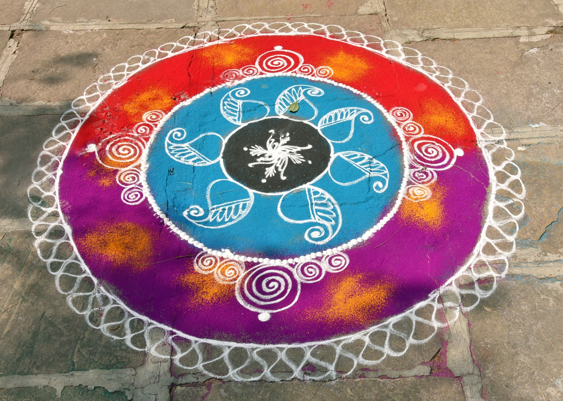

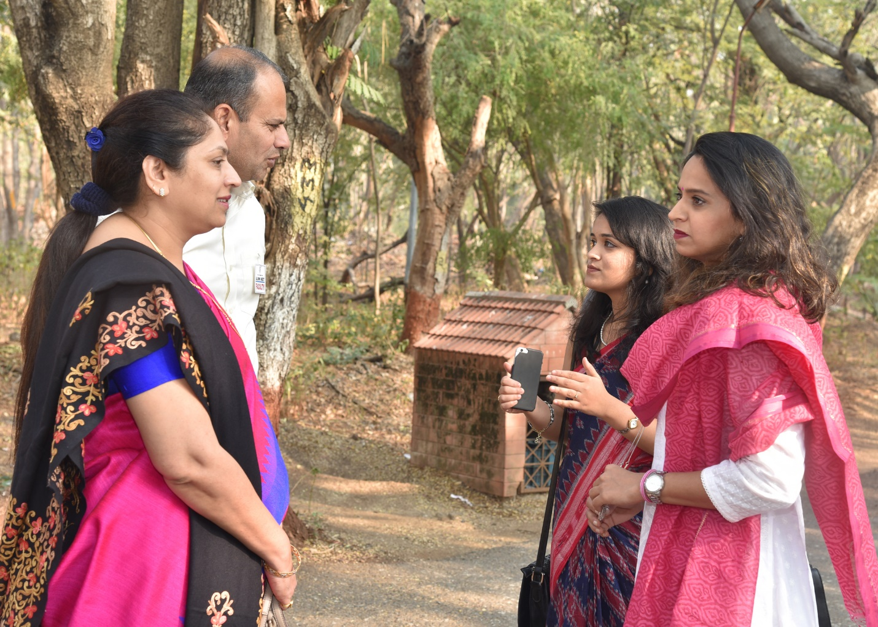
Faculty with Alumni -Ms. Apurva Bhilare and Ms. Swanandi Tikekar
Ms.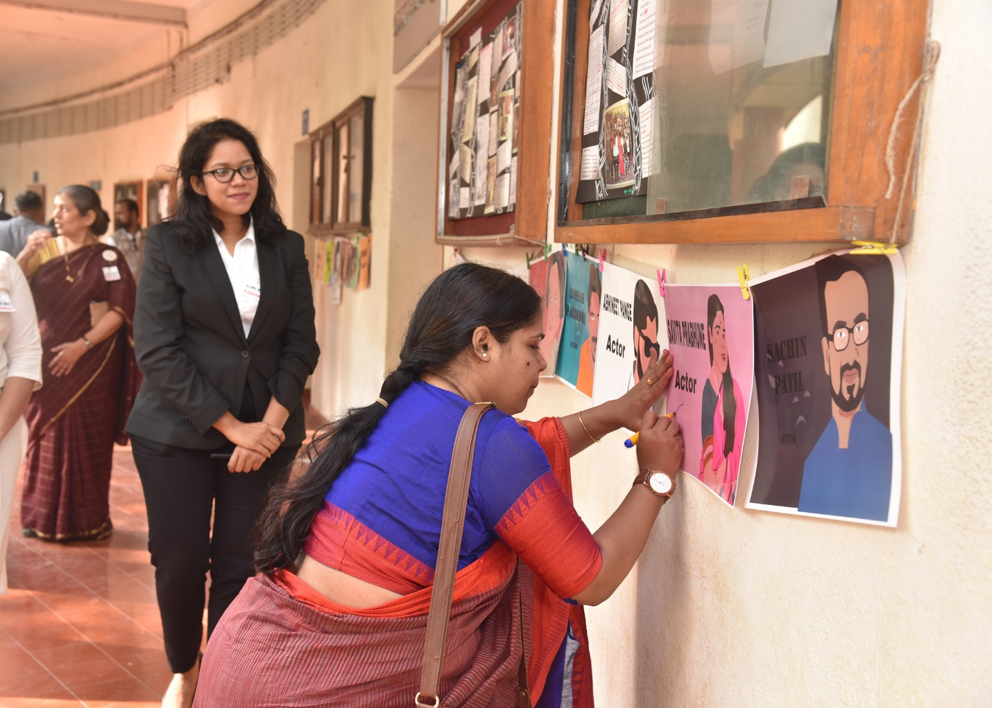
Ms. Savita Prabhune – Alumni- Actor- signing her own poster

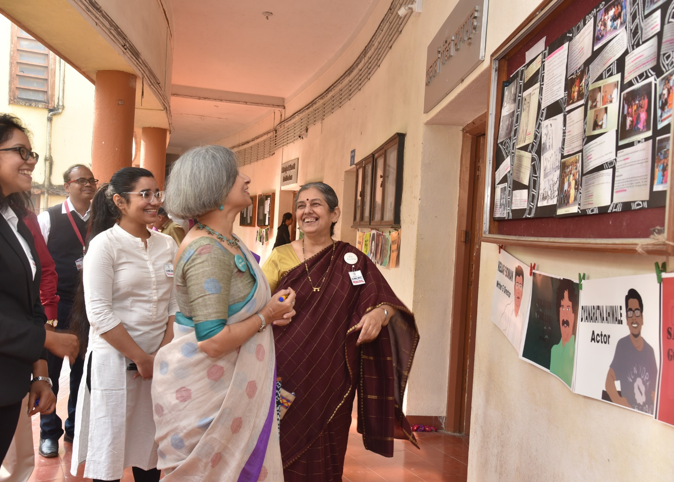
Chief Guest for the function Ms. Sandhya Gokhale- Alumni, screen writer and advocate with the Principal ILS Law college

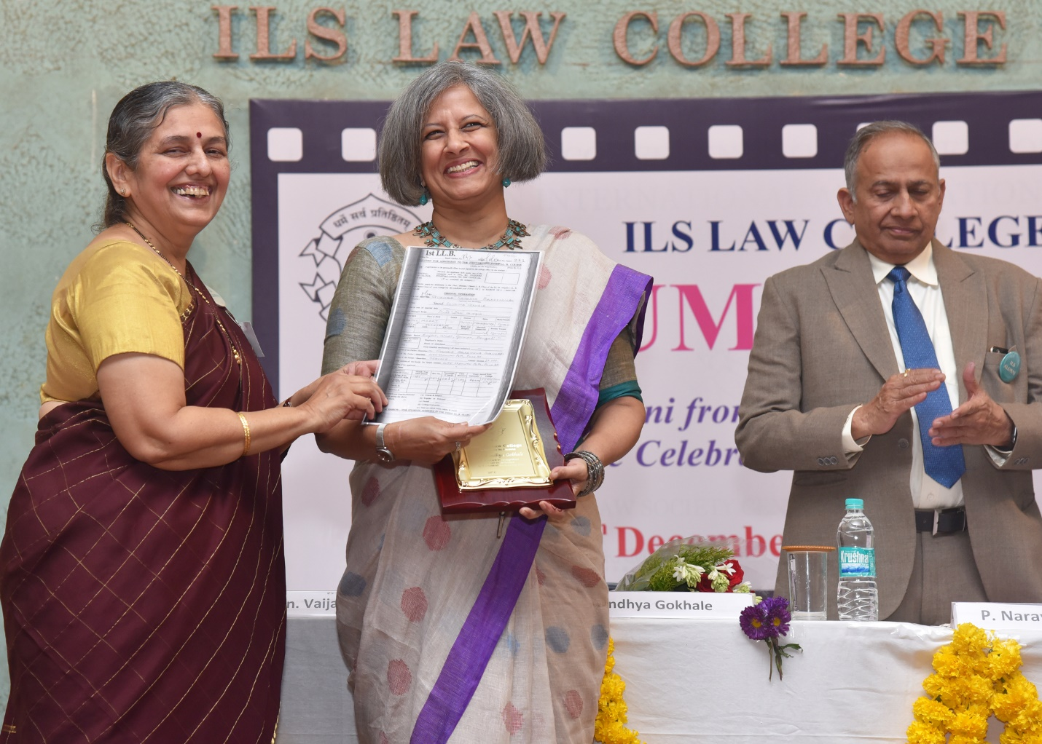
Felicitation of Ms. Sandhya Gokhale at the hands of Principal

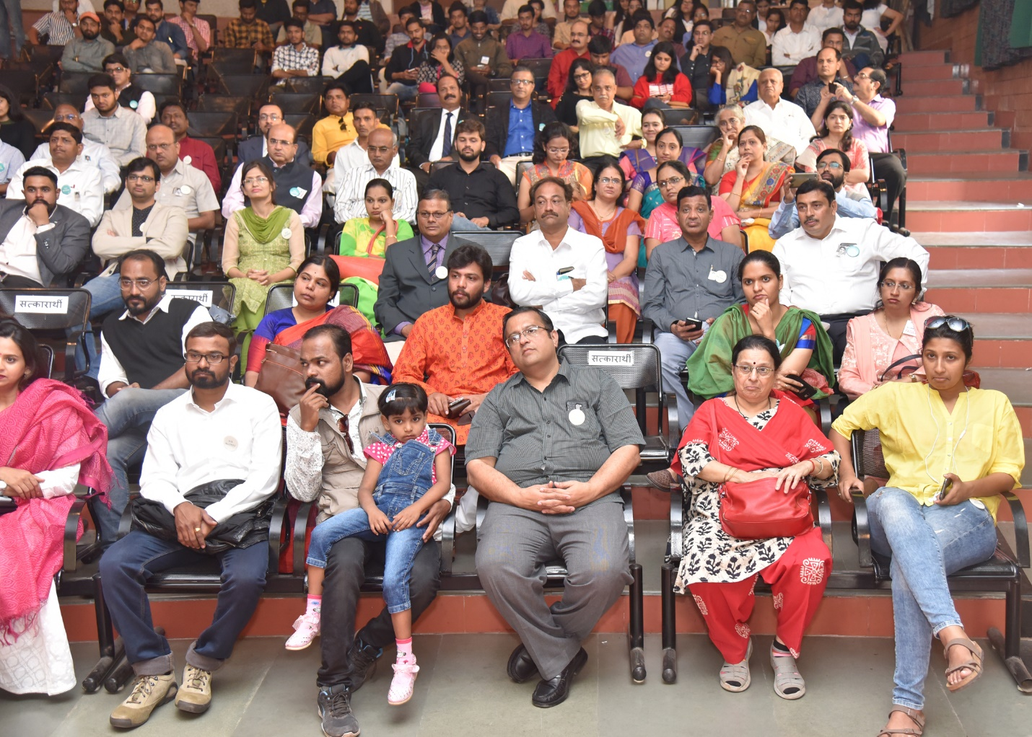
Alumni attending the function

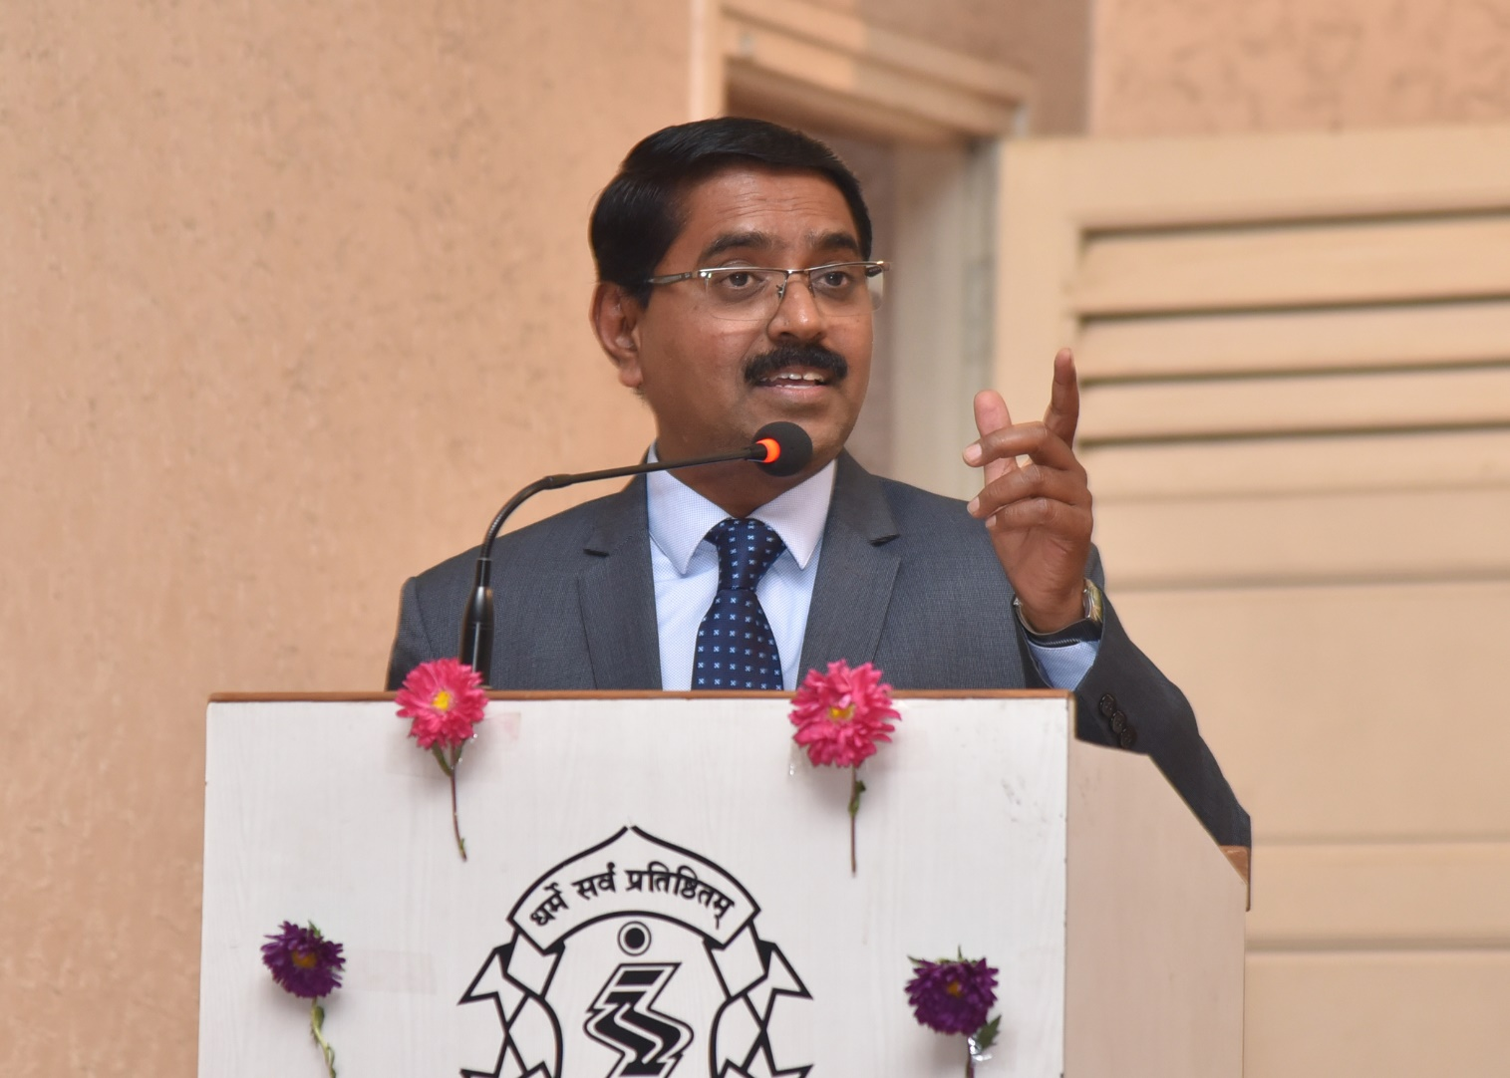
Shri. Dalvi, Alumnus from graduating batch of 1992-93 sharing his thoughts during Alumni Meet
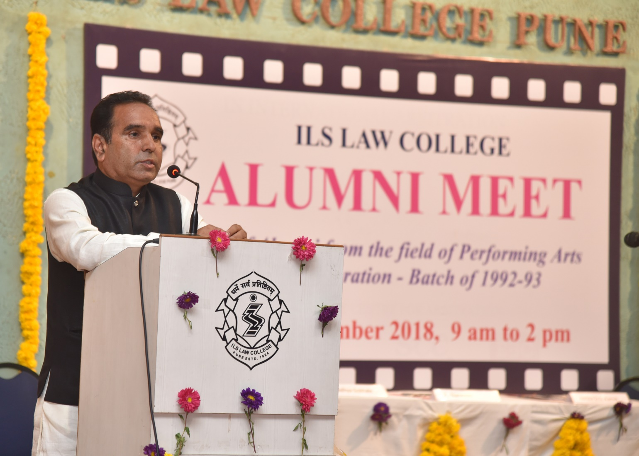
Shri. ____ Alumnus from graduating batch of 1992-93 sharing his thoughts during Alumni Meet

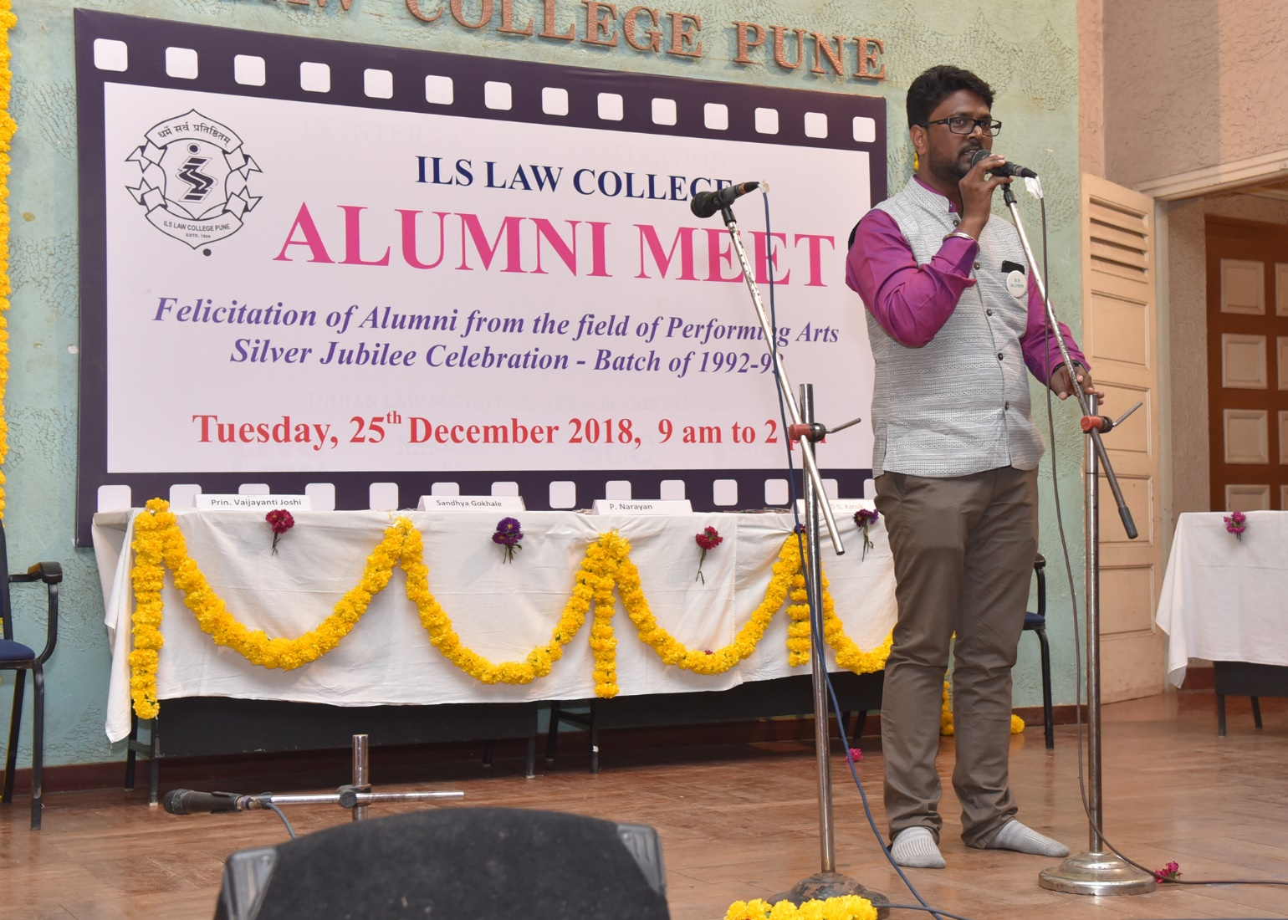
Shri. Abhijeet Dhere, Alumnus- Performing during Alumni Meet
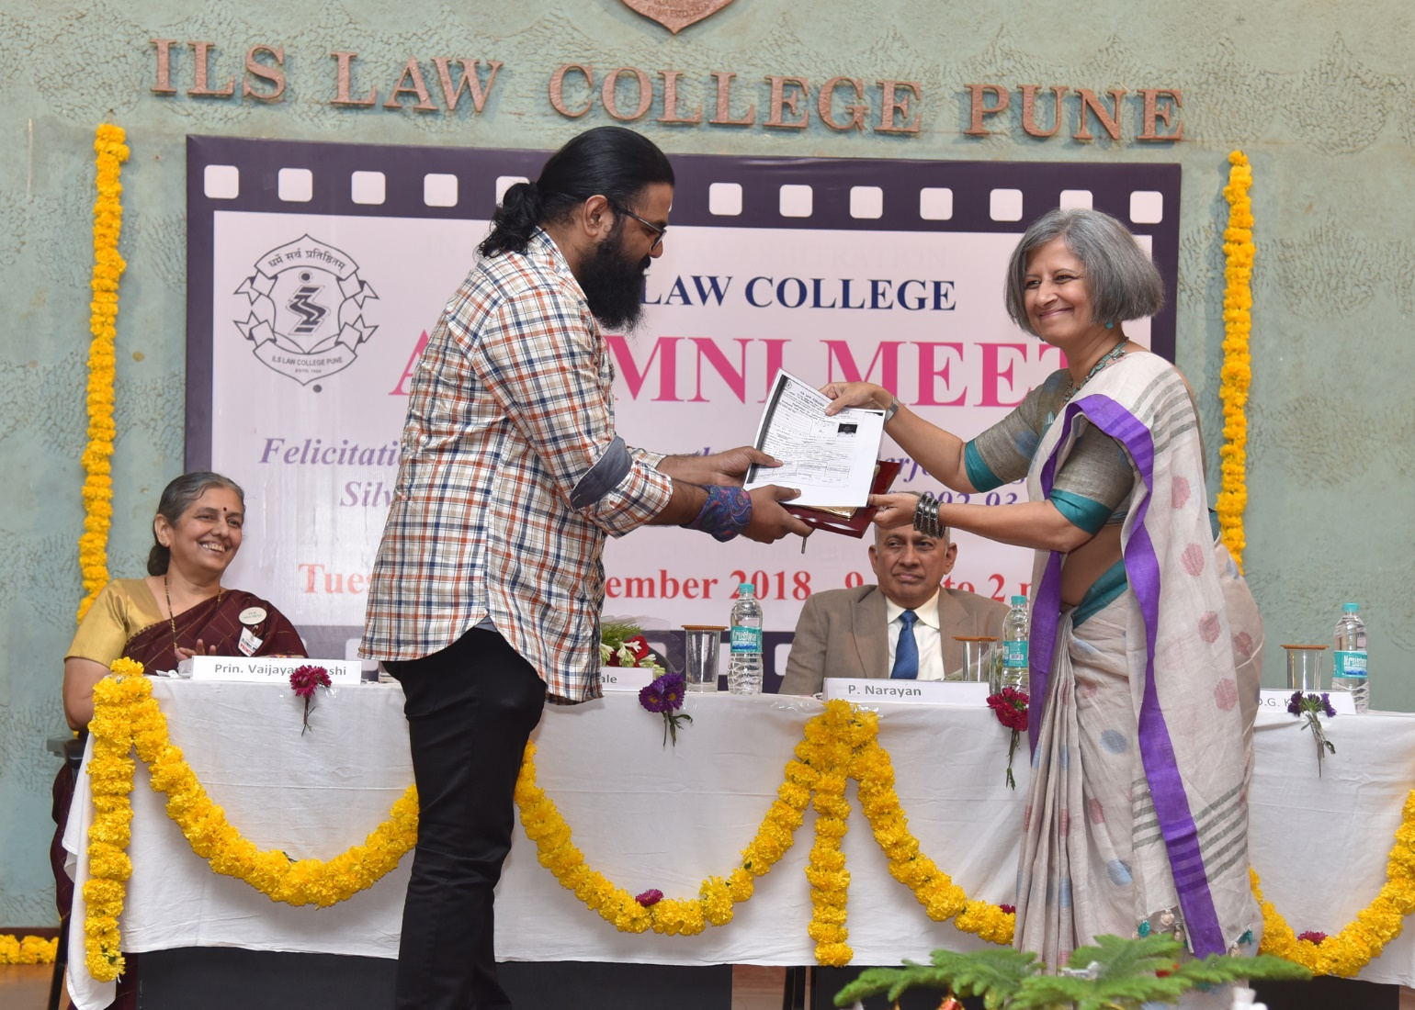
Shri. Chaitanya Solankar, Alumnus, Felicitation at the hands of Smt. Sandhya Gokhale, Alumna
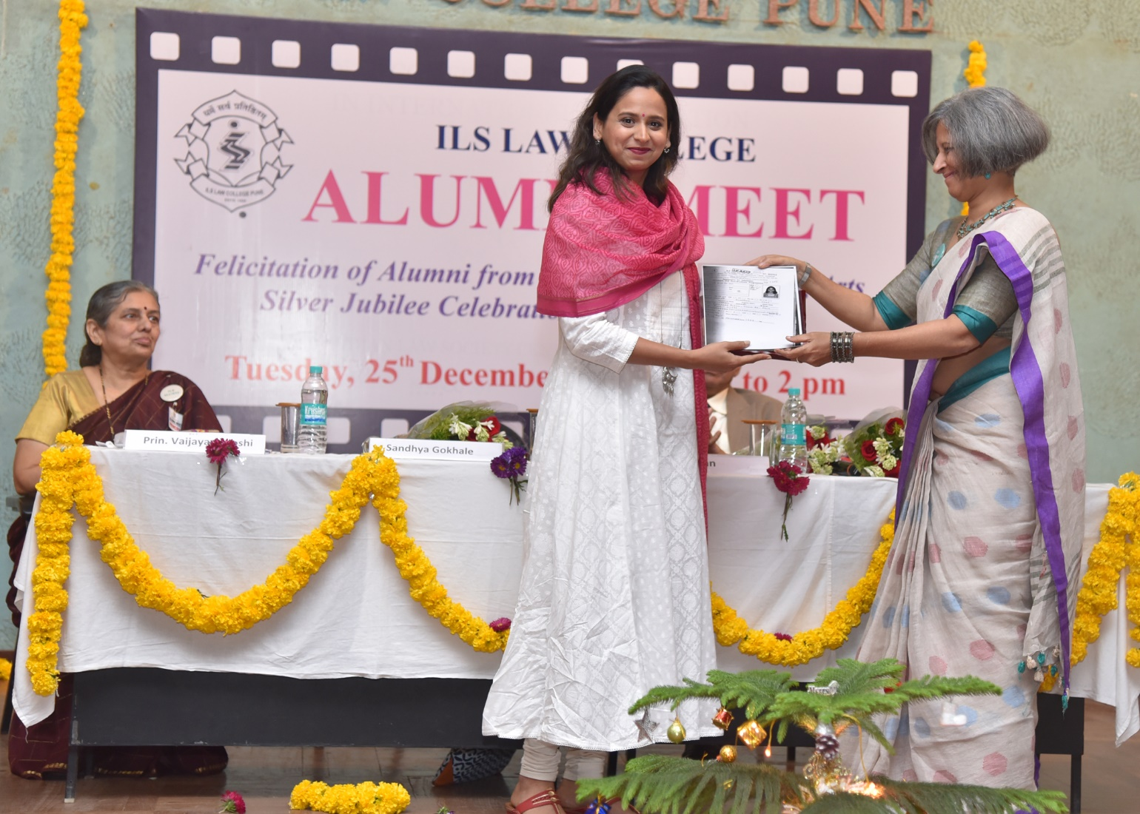
Smt. Swanandi Tikekar, Aluma - Felicitation at the hands of Smt. Sandhya Gokhale, Alumna

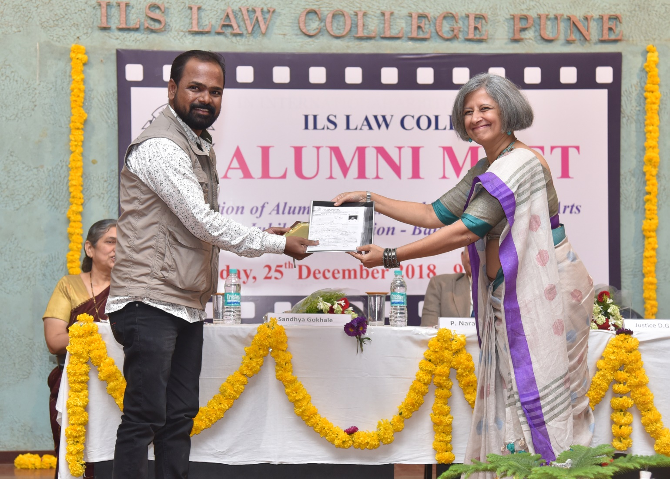
Shri. Amar Gaikwad, Alumnus Felicitation at the hands of Smt. Sandhya Gokhale, Alumna
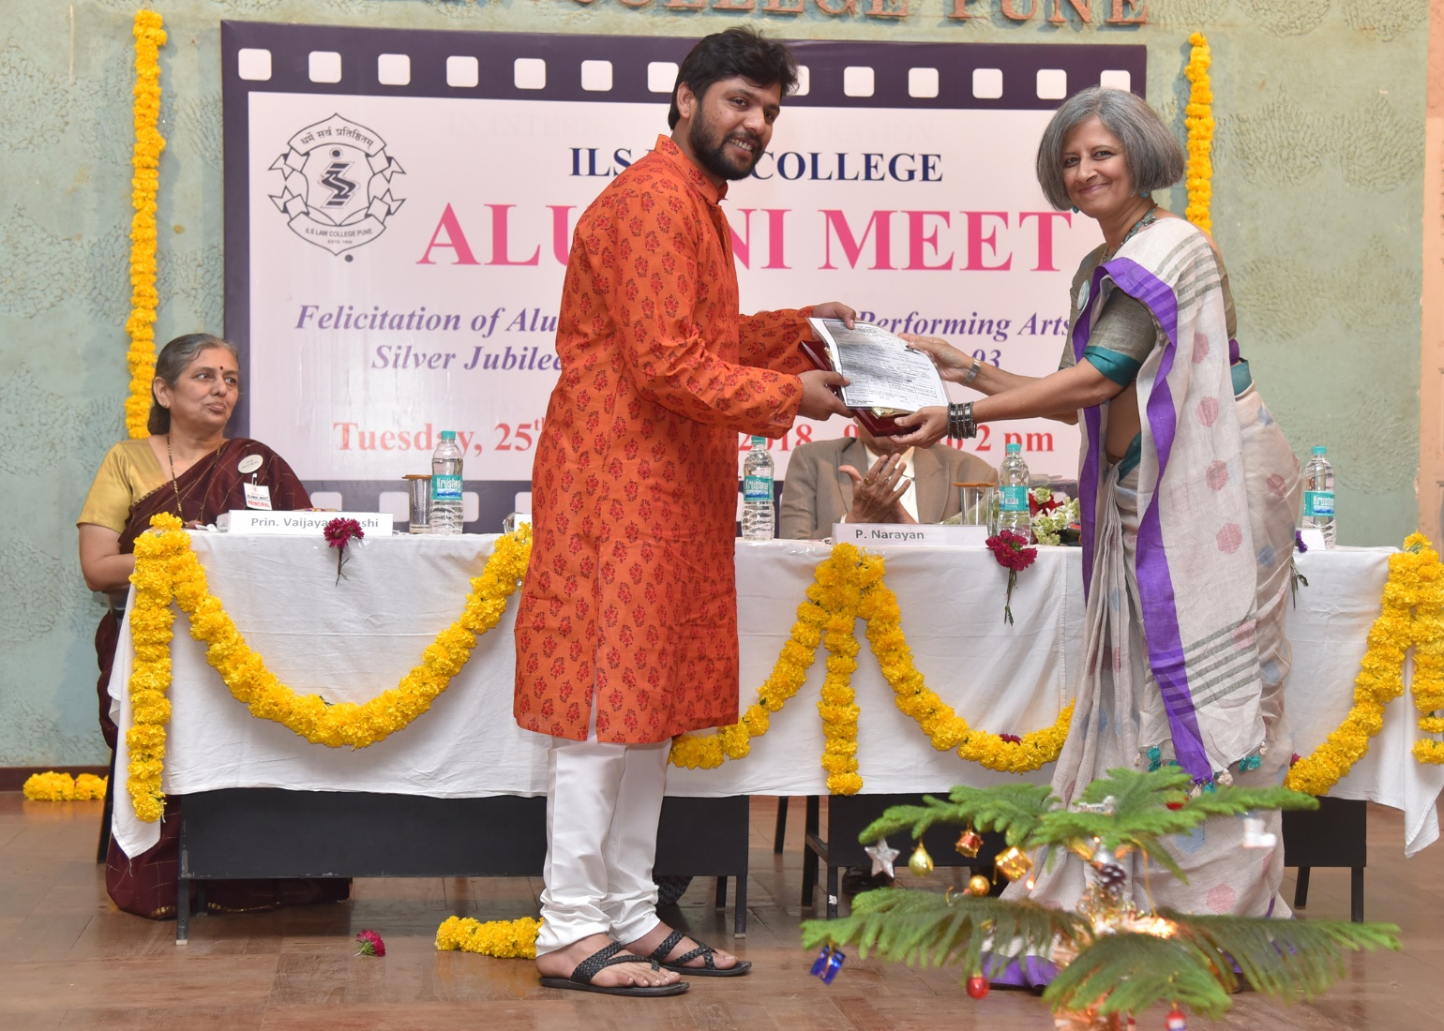 Shri. Abhineet Pange, Alumnus, Felicitation at the hands of Smt. Sandhya Gokhale, Alumna
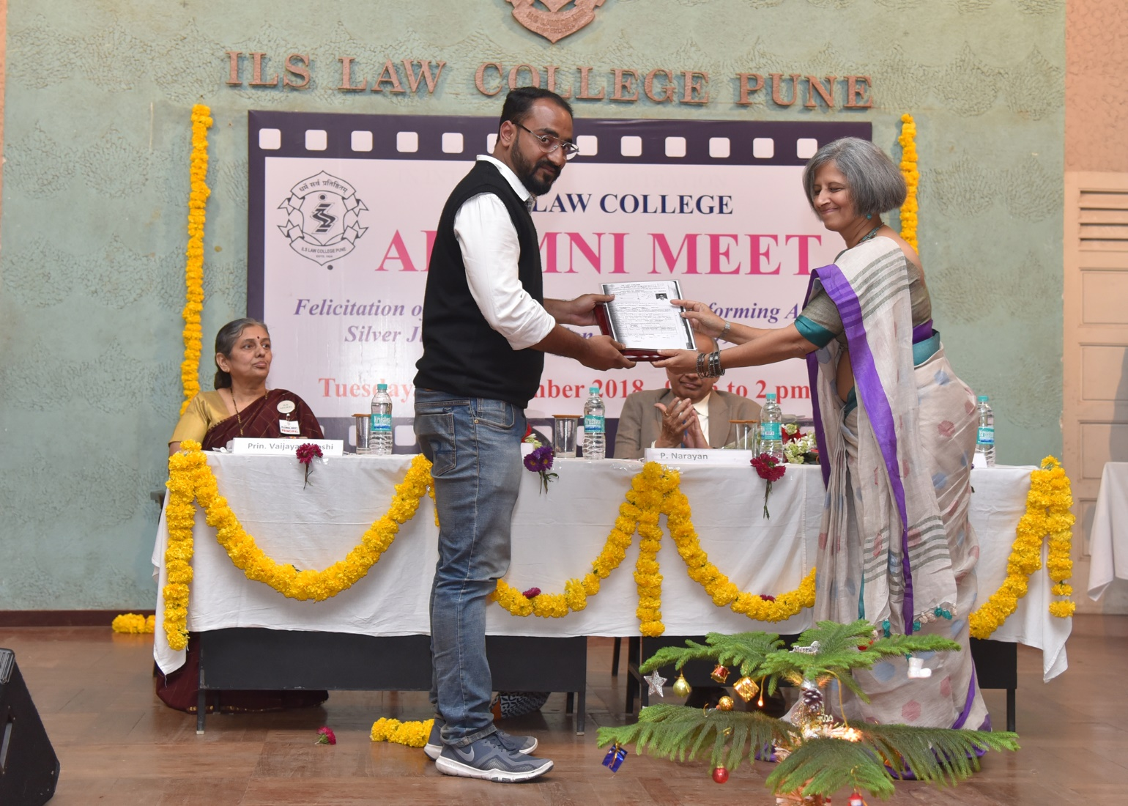
Shri. Bhushan Patil, Alumnus, Felicitation at the hands of Smt. Sandhya Gokhale, Alumna
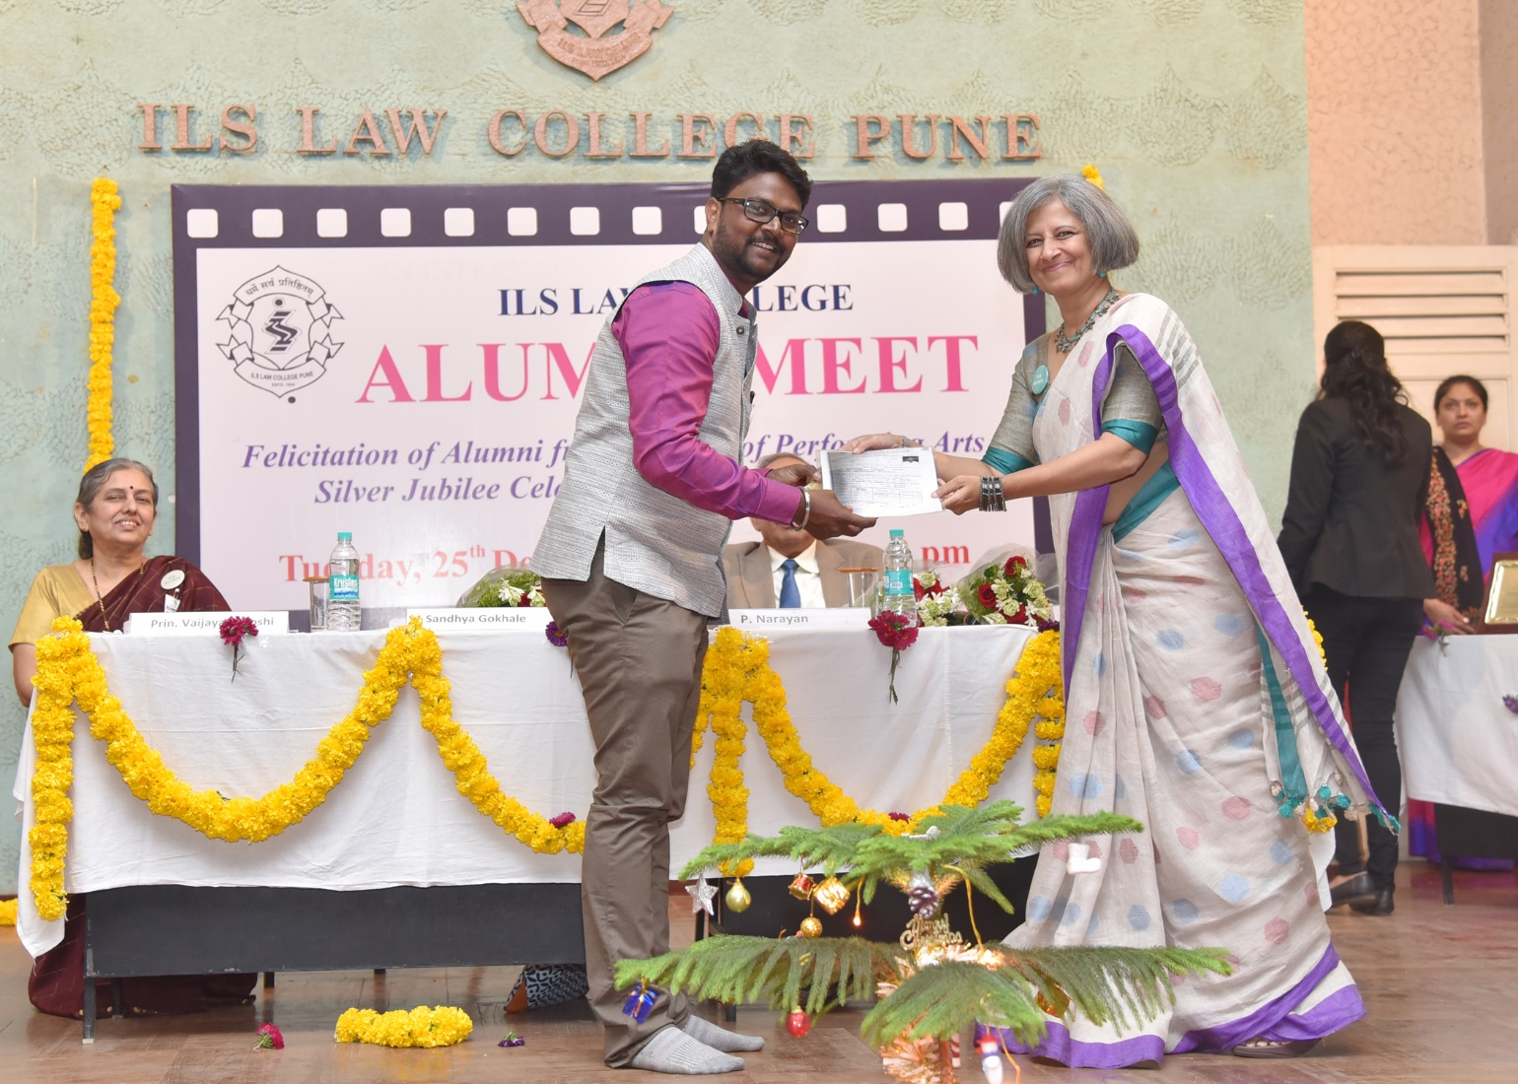
Shri. Abhijeet Dhere Alumnus, Felicitation at the hands of Smt. Sandhya Gokhale, Alumna
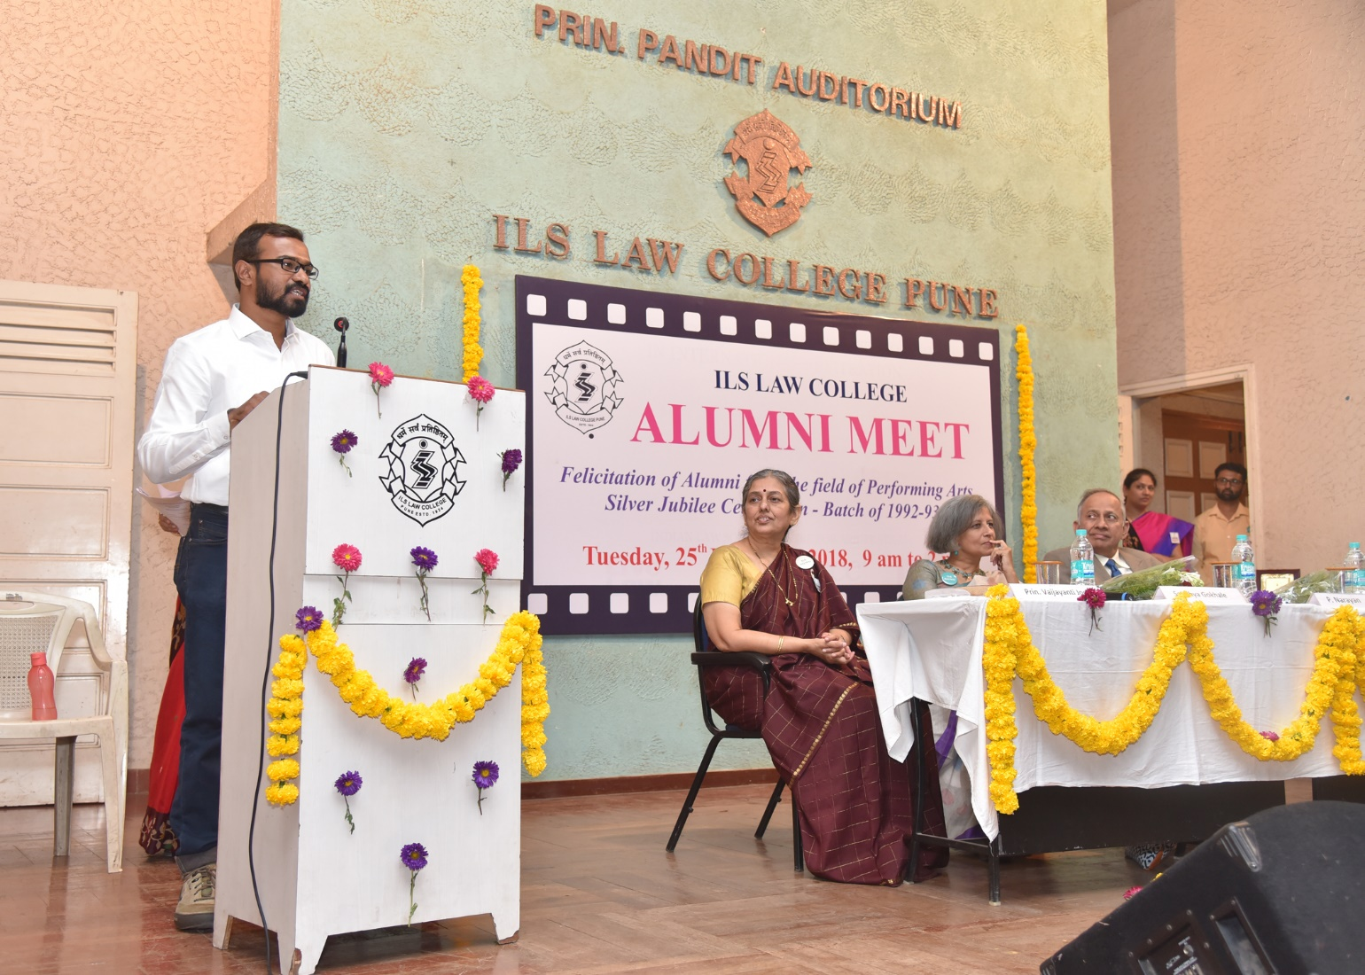
Shri. Bhushan Patil, Alumnus, Felicitation at the hands of Smt. Sandhya Gokhale, Alumna
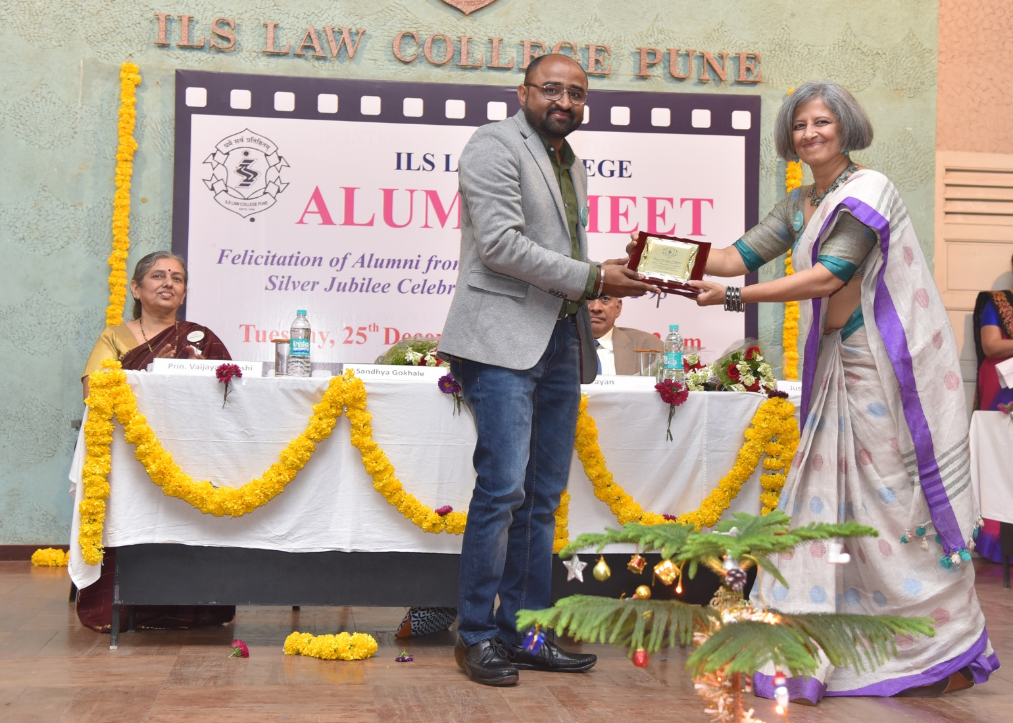
Shri. Bhushan Mehare Alumnus, Felicitation at the hands of Smt. Sandhya Gokhale, Alumna
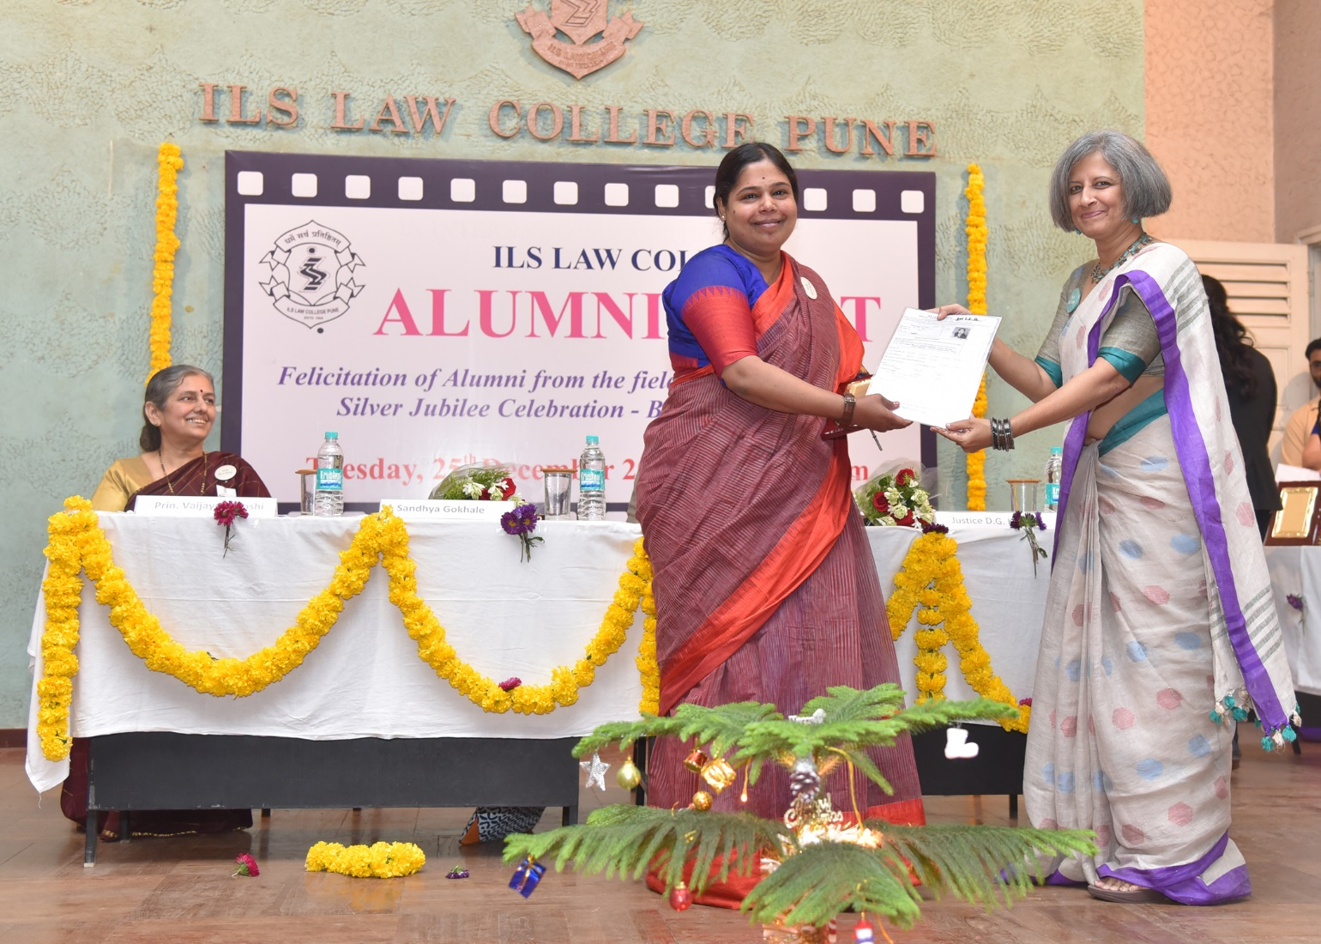
Smt. Savita Prabhune Alumna, Felicitation at the hands of Smt. Sandhya Gokhale, Alumna
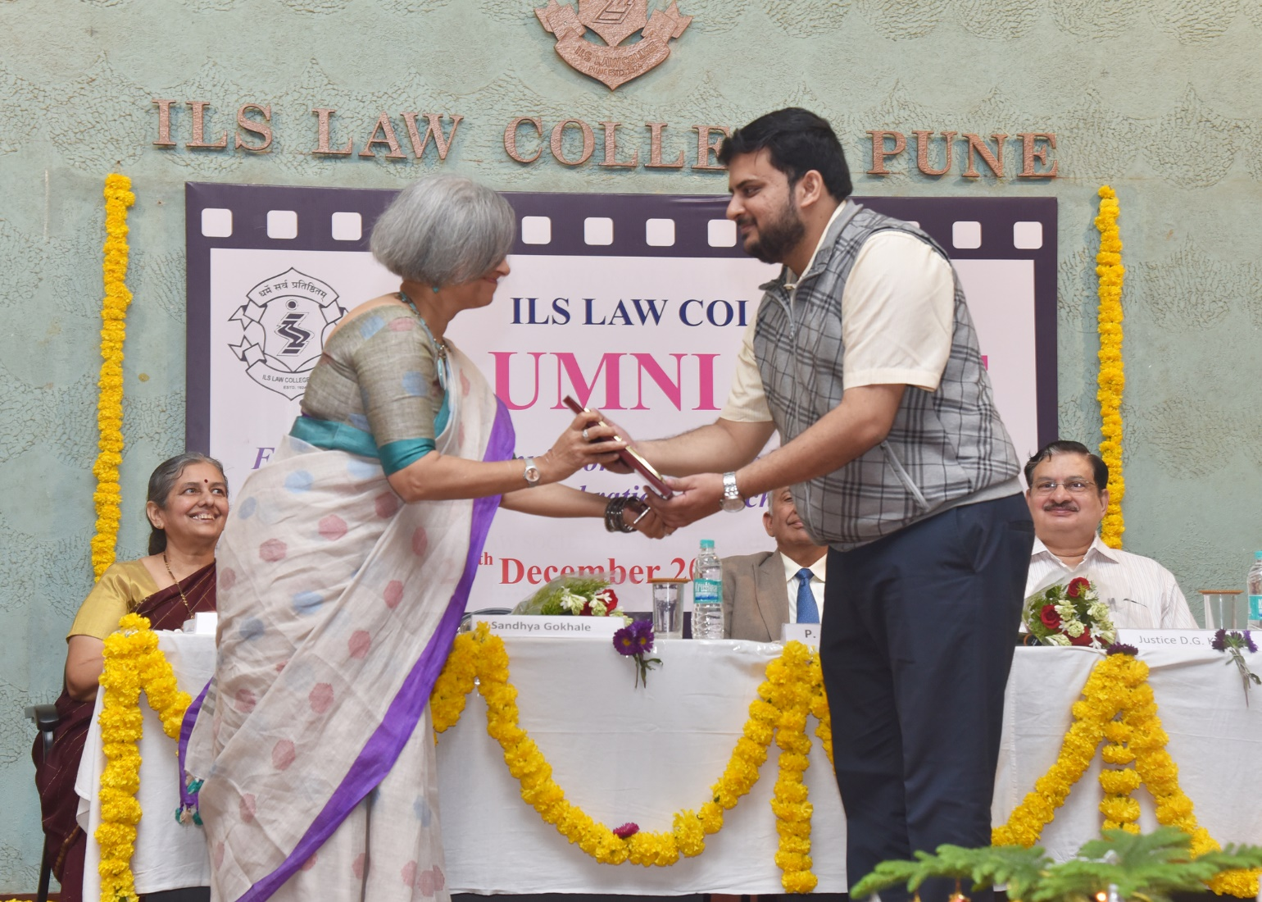
Shri. Anand Akut Alumnus, Felicitation at the hands of Smt. Sandhya Gokhale, Alumna
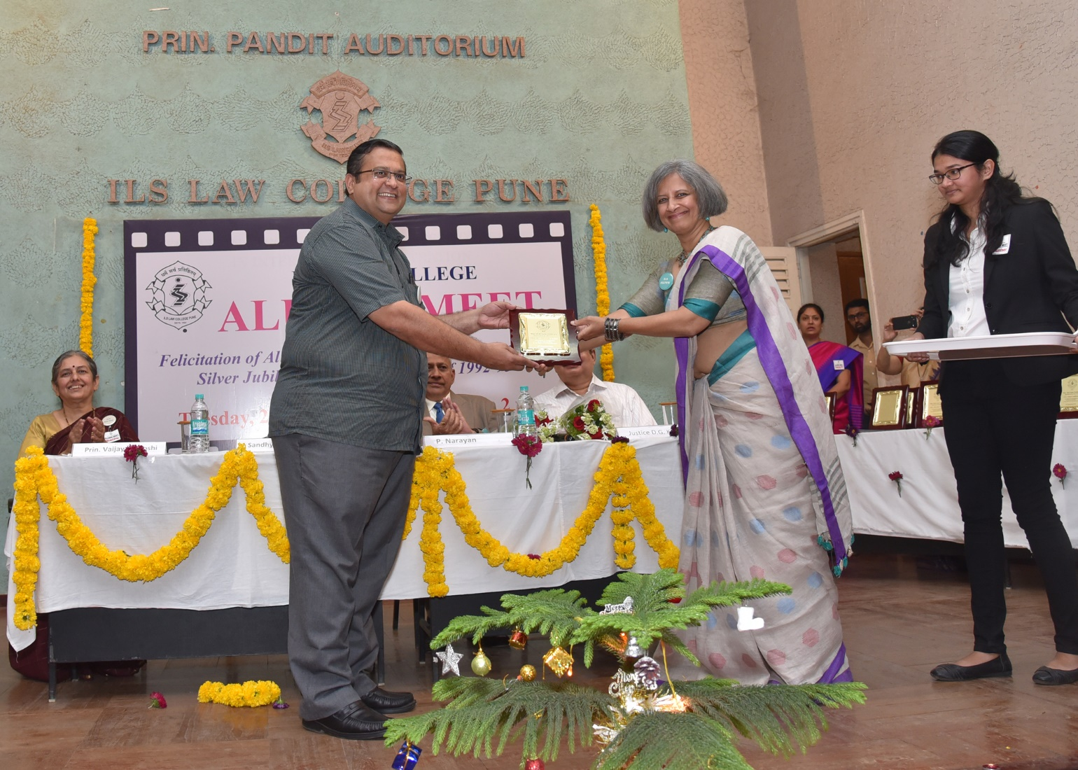
Shri. Devendra Saralkar Alumnus, Felicitation at the hands of Smt. Sandhya Gokhale, Alumna

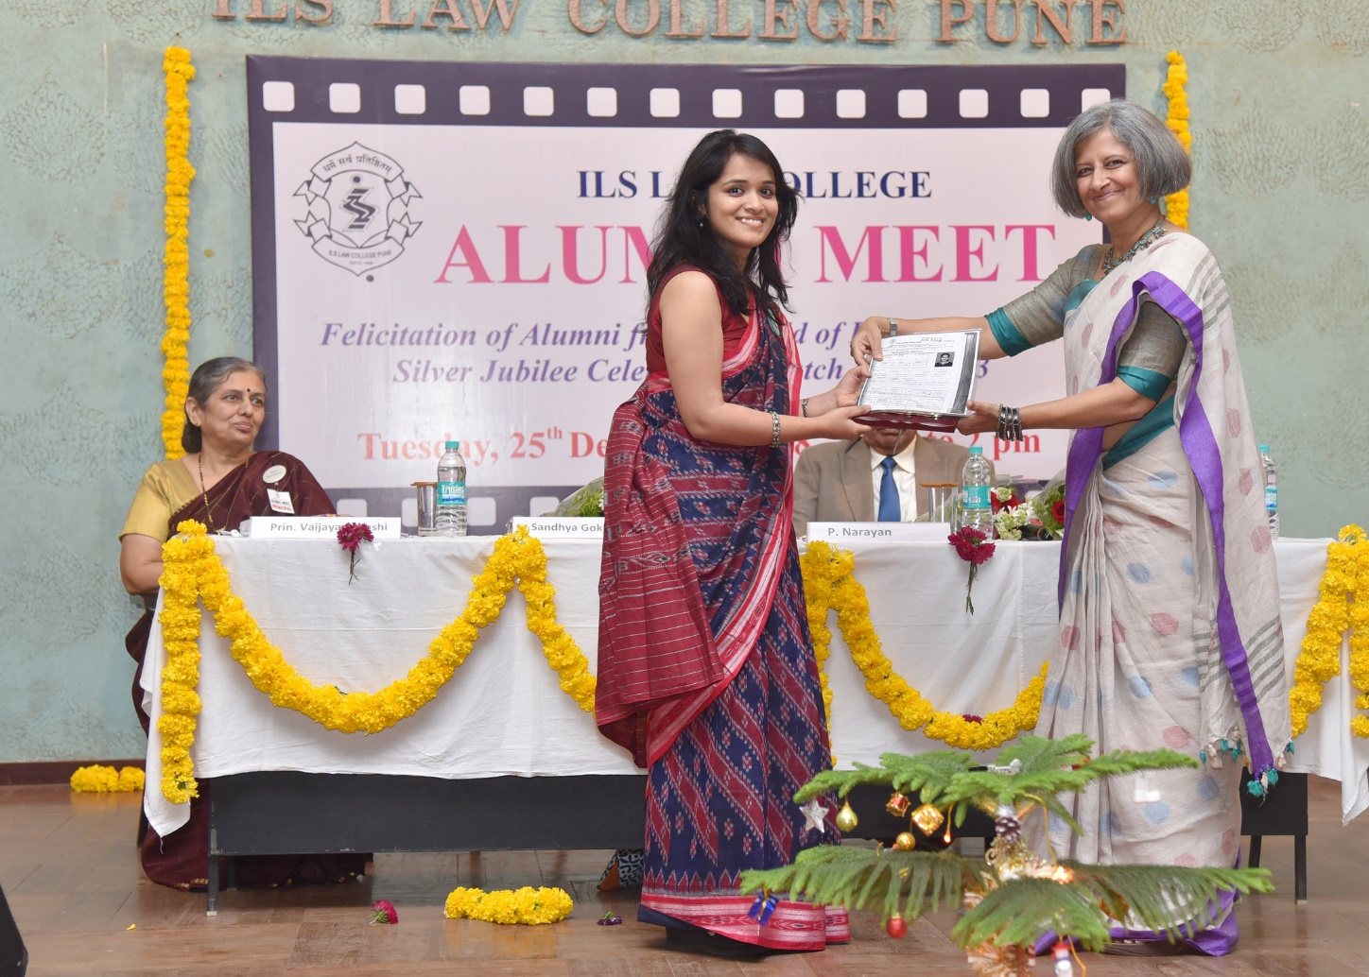
Smt. Apurva Bhilare Alumna, Felicitation at the hands of Smt. Sandhya Gokhale, Alumna

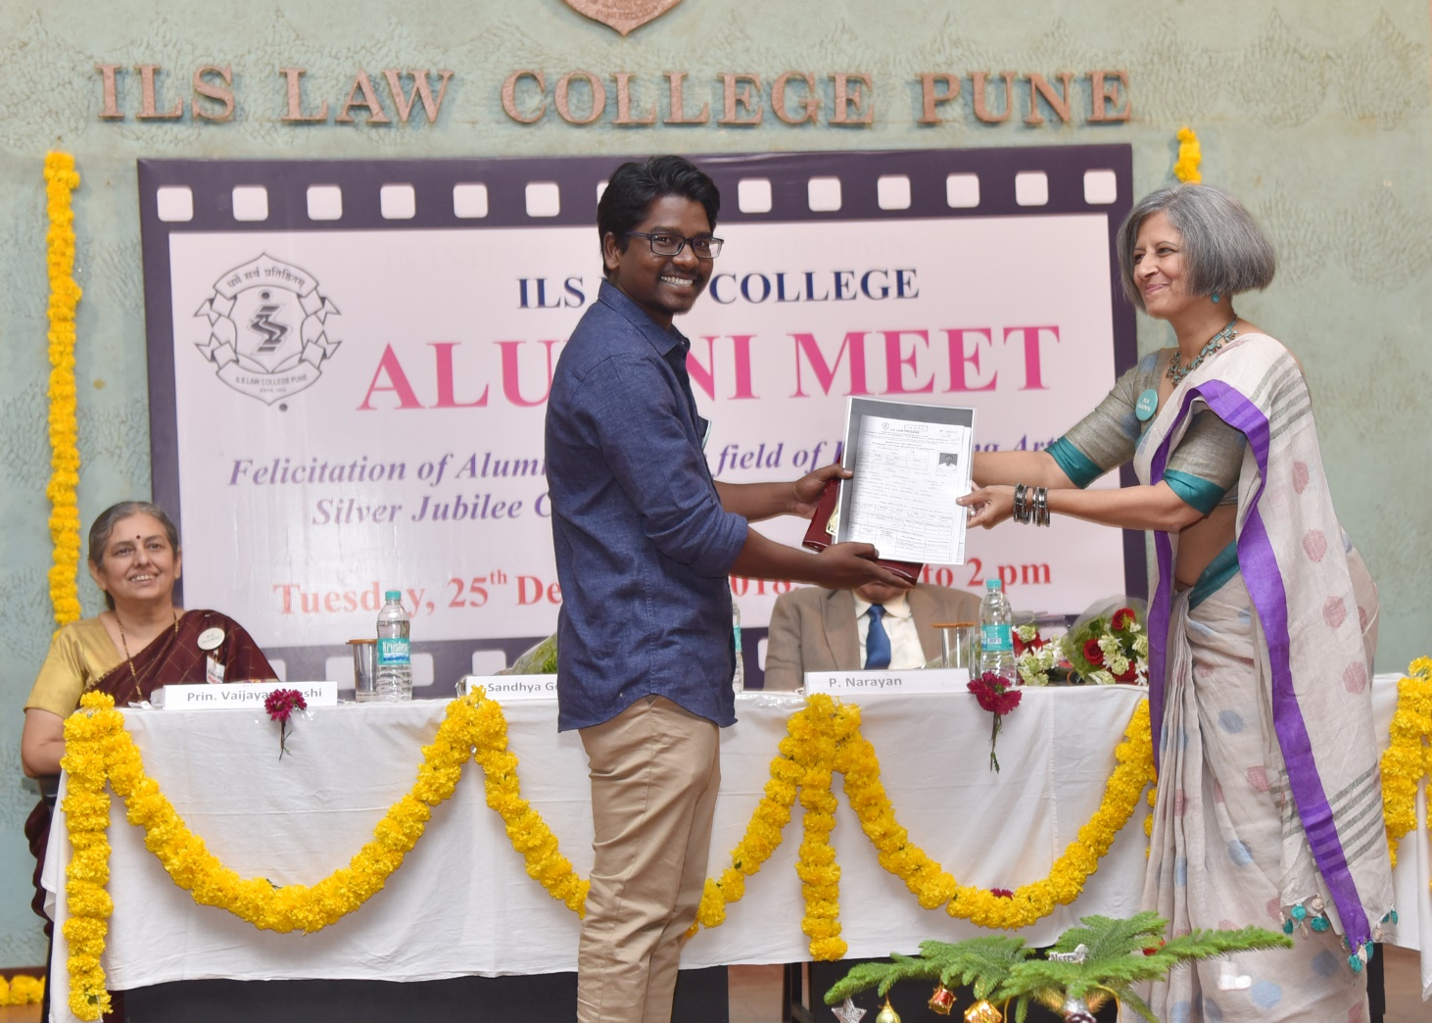
Shri. Dyanaratna Ahiwale Alumnus, Felicitation at the hands of Smt. Sandhya Gokhale, Alumna

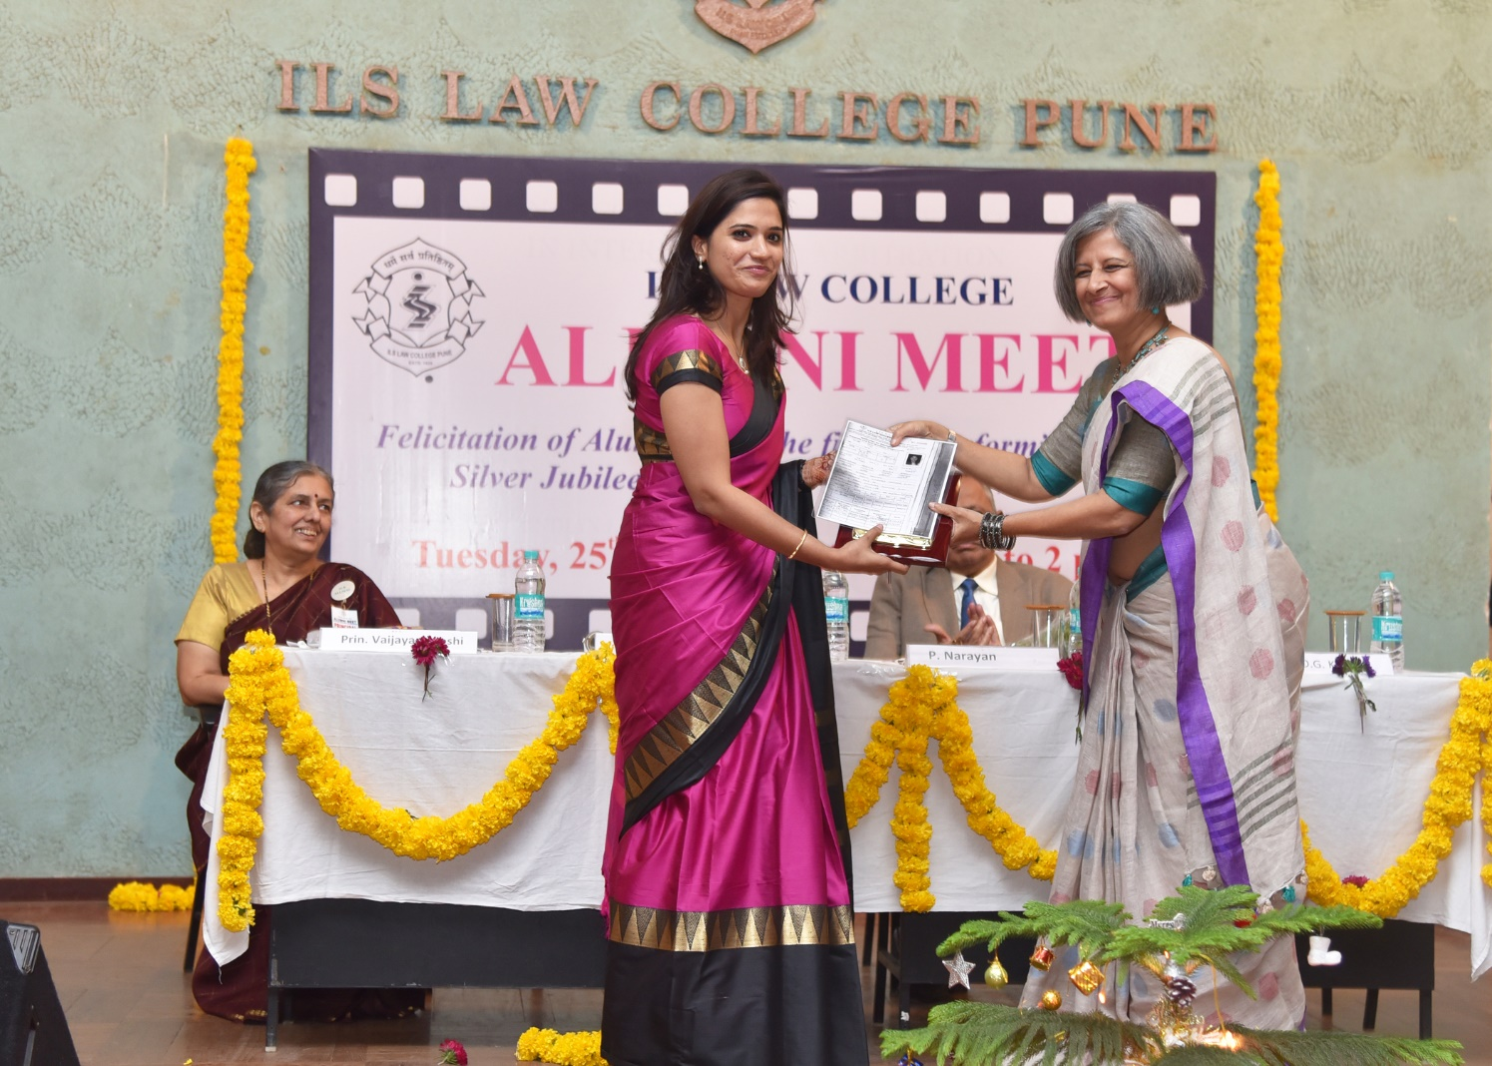
Smt. Arpita Ghoghardare Alumna, Felicitation at the hands of Smt. Sandhya Gokhale, Alumna

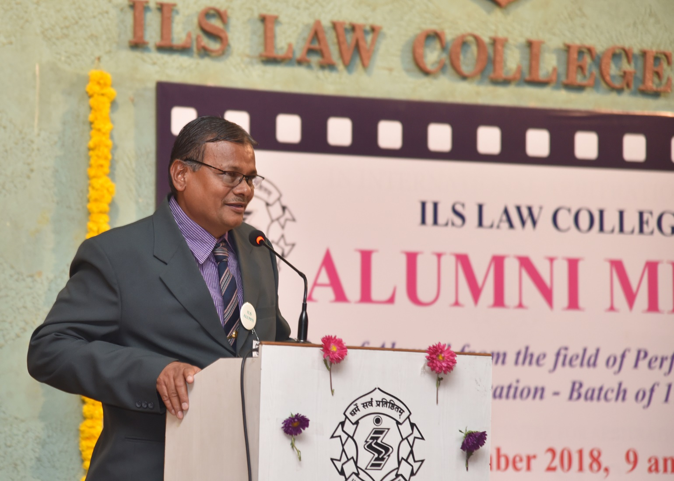
Shri. ____ Alumnus from graduating batch of 1992-93 sharing his thoughts during Alumni Meet

