ILS_manage Notes:

>Internal Assessent - Write Manage Development Note:
– Modules
– Pages
– Services
– Notifications (Mail content and Subject will be provided)
– CPT, Taxonomy etc.
– DB meta_keys and the structure, table etc.
– Record activity (write all the details that need to track and record).

>Management information about data(Manage Screen):
1-We are showing information about data of organization(Management can be defined as the process of administering and controlling the affairs of the organization).

2-Management is a set of principles relating to the functions of planning, organizing, directing and controlling, and the application of these principles in harnessing physical, financial, human and informational resources efficiently and effectively to achieve organizational goals.

URL: http://ils.wordpoets.com/manage/
Manage_screen:
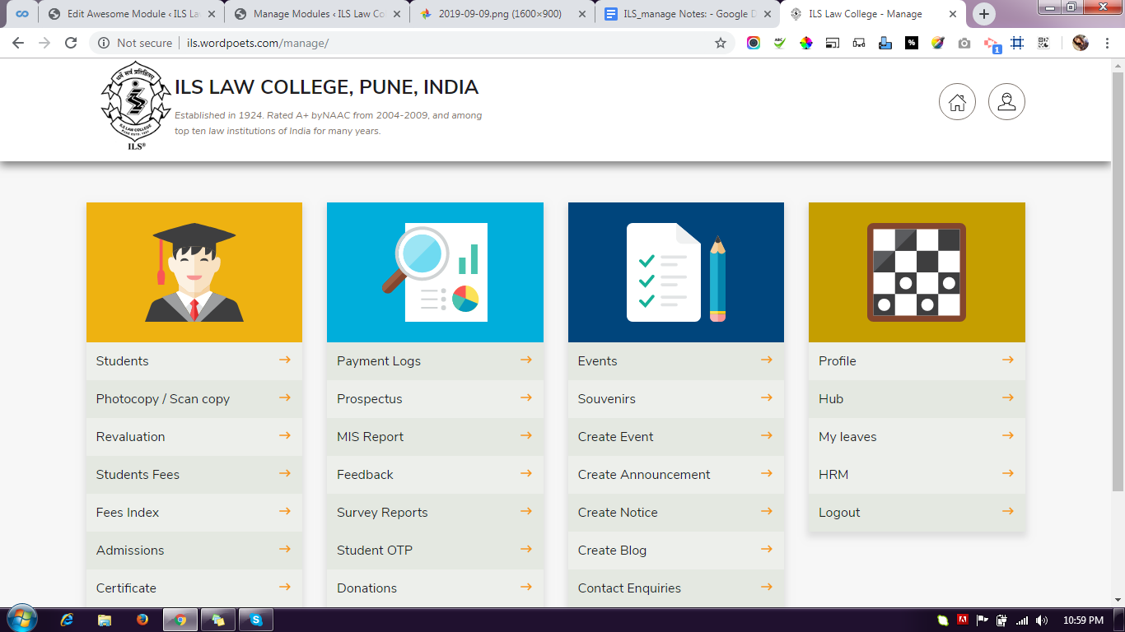
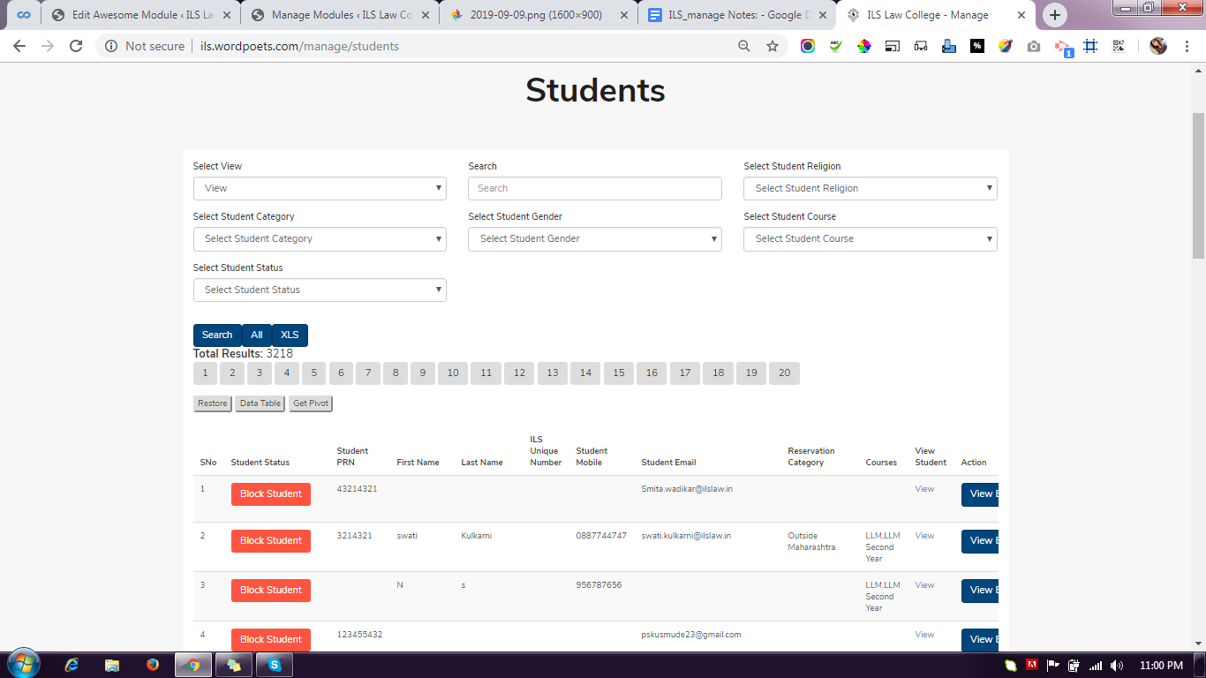

Manage Modules:
Home : { http://ils.wordpoets.com/wp-admin/post.php?post=20533&action=edit }

Inner-page-tab (Navigation menu):
http://ils.wordpoets.com/wp-admin/post.php?post=46382&action=edit

Student Internal Assessment Module:
student-internal-assessment : http://ils.wordpoets.com/manage/student-internal-assessment

Internal-assessment Module: post_type='content_model'
http://ils.wordpoets.com/wp-admin/post.php?post=114025&action=edit

Internal-assessment-single : view: Single page
http://ils.wordpoets.com/wp-admin/post.php?post=114080&action=edit

