Note: Internal assessment - Migration note
Building a form web page with help of all modules (static and dynamic work)
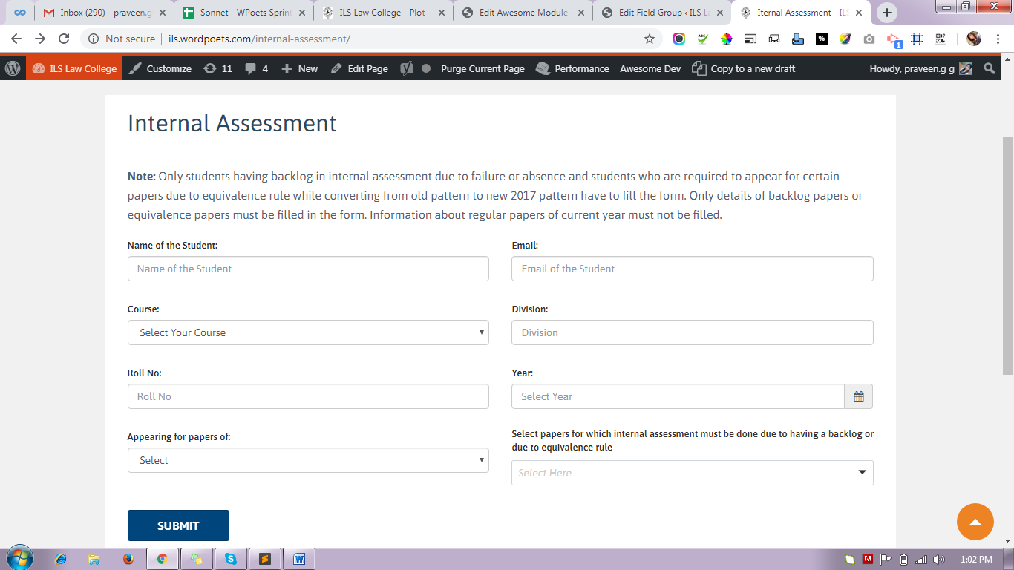
Step 1:
Form Page Name: internal-assessment
URL: http://ils.wordpoets.com/internal-assessment/
Module Name(display form in web page): Internal assessment (called this module into a page)
URL: http://ils.wordpoets.com/wp-admin/post.php?post=113021&action=edit
Step 2:
Created a CPT(Post_type) using CPT UI
CPT Name:internal_assessments
Step 3: Below (screen_shot)
Created Custom field > Field Groups Name: Internal Assessment Meta
create meta field which field have in our form for post meta and assign post_type (Internal Assessment)
Note: You can also export CPT duration migration time but ask with senoir how to do if you don't know.

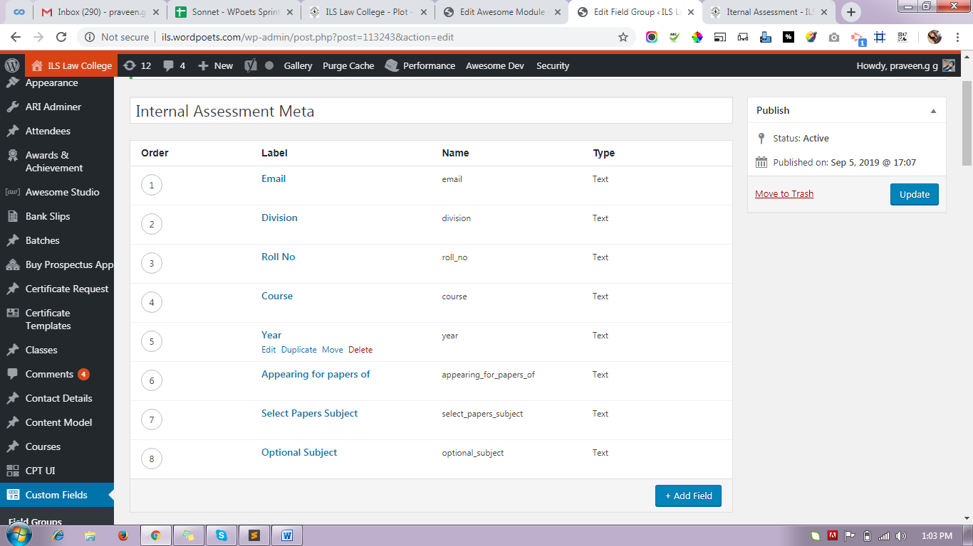
Step 4: Save part query
Module Name: internal-assessment-handler (this module using for form data save in backend also mail notification)
URL: http://ils.wordpoets.com/wp-admin/post.php?post=113210&action=edit
Manage part:
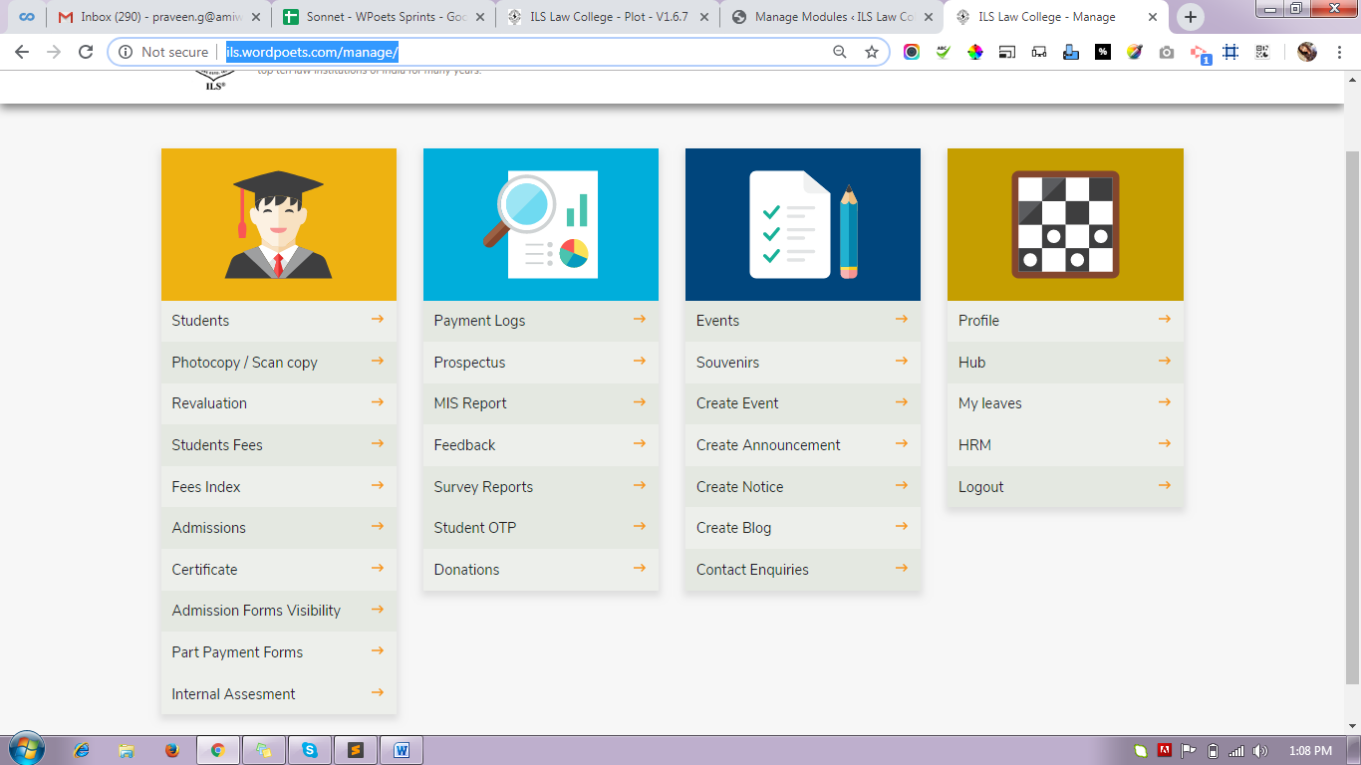
http://ils.wordpoets.com/manage/
Step 1 : GO TO Manage App for manage pages and modules
Add your Internal Assessment dropdown here
Module Name: Home
URL: http://ils.wordpoets.com/wp-admin/post.php?post=20533&action=edit
Inner-page-tab (Navigation menu):
http://ils.wordpoets.com/wp-admin/post.php?post=46382&action=edit

Step 2 :
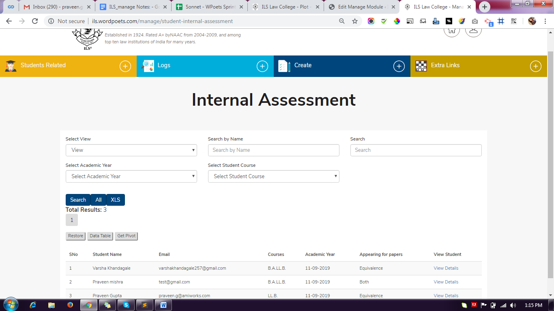
Student Internal Assessment Module:
student-internal-assessment : http://ils.wordpoets.com/manage/student-internal-assessment

Create a module (Internal-assessment) with in post_type='content_model
Note: This module we are creating for table content and fetching data from post.
post_type (internal-assessments).
Internal-assessment Module: post_type='content_model'
http://ils.wordpoets.com/wp-admin/post.php?post=114025&action=edit

Step 3: Single View Page

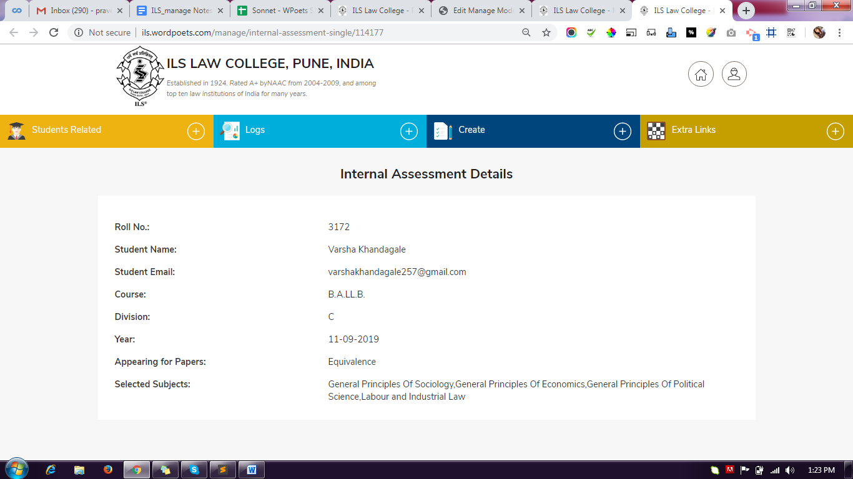

Module > Internal-assessment-single :
http://ils.wordpoets.com/wp-admin/post.php?post=114080&action=edit

Single page View page URL:
http://ils.wordpoets.com/manage/internal-assessment-single/114177

