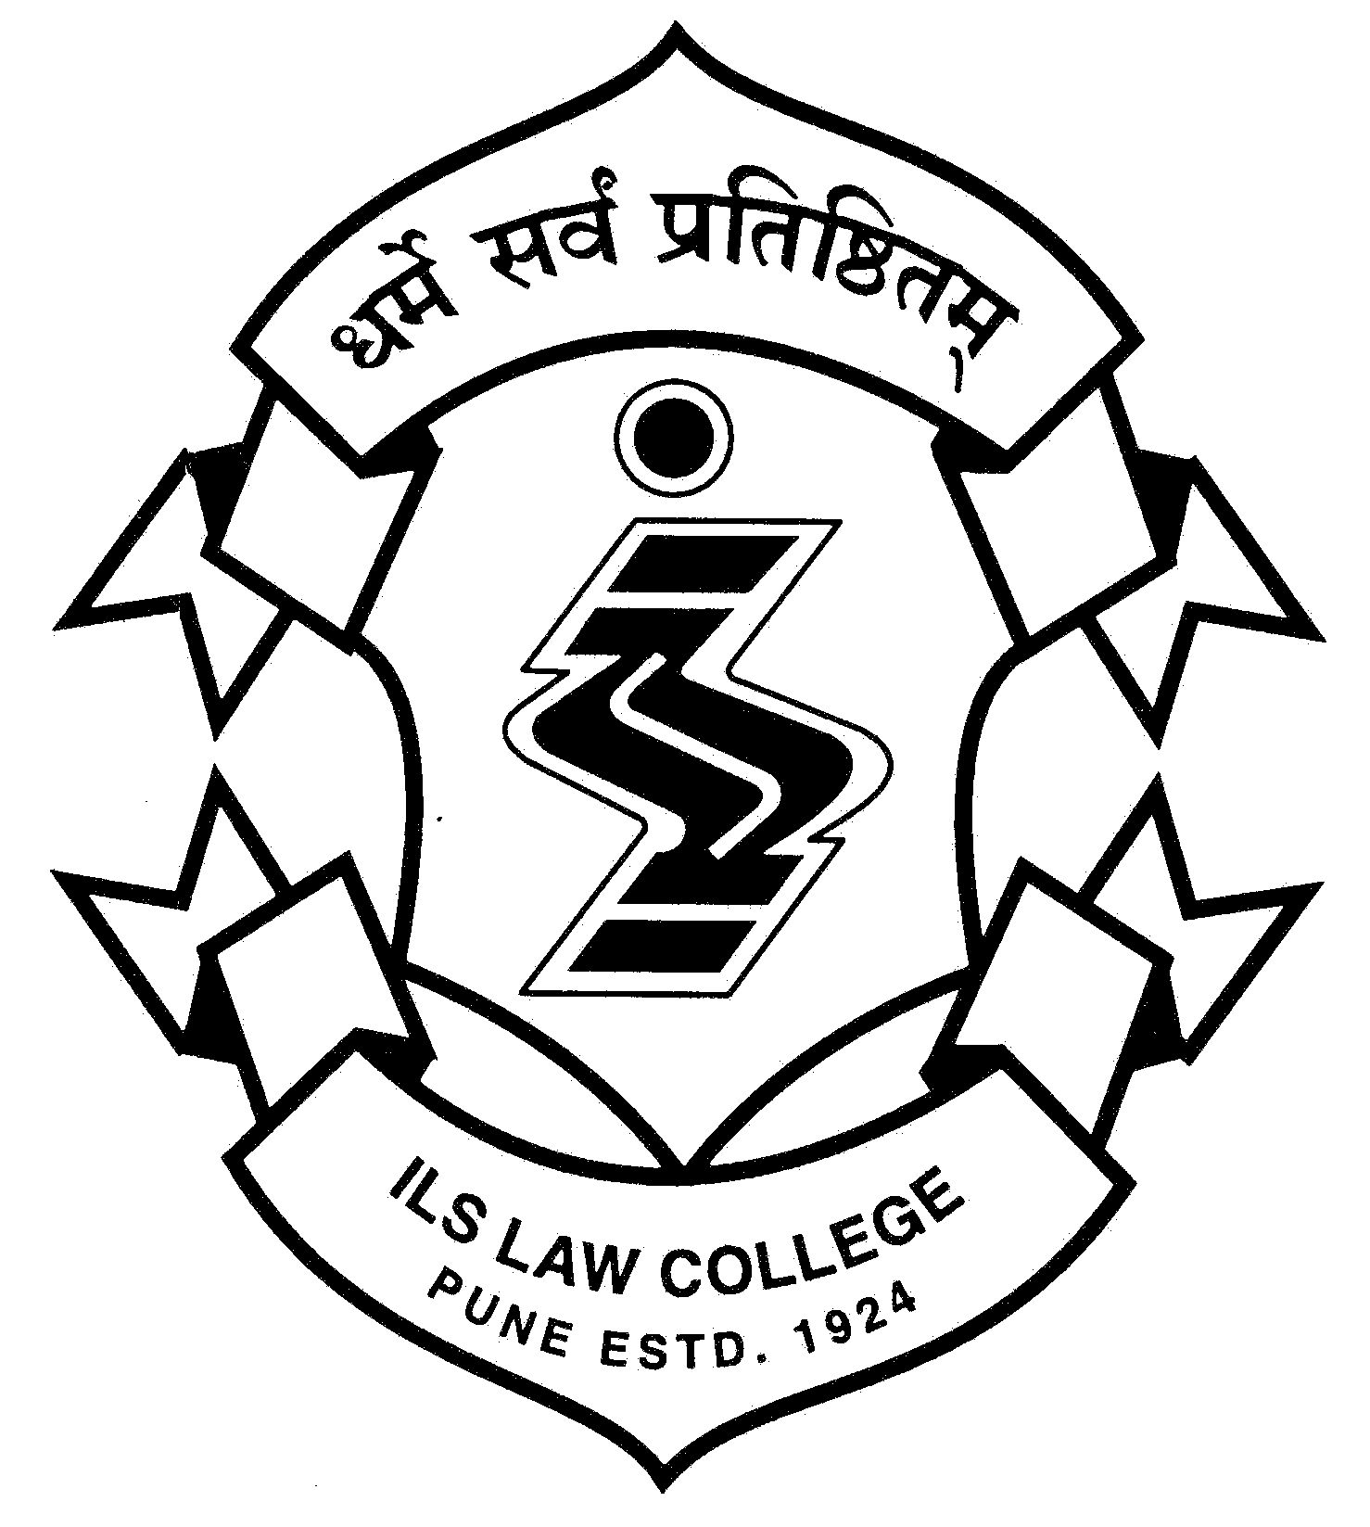  ®  ILS | ILS Law College  Law College Road, Pune 411 004  Tel: 020-25656775, 020-25656780  email: ilslaw@ilslaw.in, web: www.ilslaw.edu  (accredited A level by NAAC (2019-2024)

Admissions 2020-21
First Year of the Five Year Law Course
Round – 1
(8th February to 12th February 2021)
Excluding Sunday and Public Holiday

Taking into account the pandemic, all students and parents are requested to observe all norms of social distancing i.e. wearing face masks, use of sanitizers, keeping social distance etc.

The admission procedure is as follows -

General

- The candidate, who is allotted ILS Law College, must personally attend the admission process. Please find below the schedule.
- The candidate must bring all original documents for scrutiny for the purpose of admission. The College will not admit the candidate if he / she does not have all original documents at the time of admission.
- The College will not admit the candidate if :-
  - he / she does not personally attend the process, OR
  - he / she does not bring original documents for our scrutiny at the time of admission process, OR
  - his / her documents are not complete, OR
  - he / she does not pay fees , OR
  - he / she does not complete other formalities, OR
  - he / she is not eligible under the rules and provisions applicable to admissions.
- The candidate must complete the admission procedure within prescribed time limit given in the schedule.
- Except the Principal, no other person is authorized to grant or to promise or to make any representation regarding admissions.
- All admissions are provisional and subject to further approval by the Savitribai Phule Pune University and CET Cell.

IMPORTANT NOTE:
- The candidate is NOT eligible for admission if he / she does not possess Provisional allotment letter.
- Candidate must bring a soft copy of his / her recent photograph of size between 20 KB and 100 KB in .PNG or .JPEG format

Admission Schedule – Round 1
8th February to 12th February 2021
Admission Procedure from 10.00 am to 4.00 pm at Laxmi Building, ILS Law College, Pune.
Time | Details
10.00 to 1.00 pm | Registration at Laxmi Building
1.00 to 1.30 pm | Lunch break
12.00 to 4.00 pm | - Verification of documents  - Online filling up of Forms and printing at ILS Law College  - Submission of Forms, Payment of fee, Issue of roll number and Identity card

Documents
Candidates must bring with them and submit at the time of CAP Round 1, the ORIGINAL and two self-attested copies of the following documents.
Mandatory Documents-For all Candidates
S No | Type of Candidate | Attested true copies should be brought
1 | All Candidates.  [Maharashtra State Candidate, Outside Maharashtra State  Candidates (All India Candidature) including Jammu  & Kashmir Migrant  Candidates] | 1) SSC (Std. X) Mark sheet.  [If candidate has Passed SSC from CBSC, ICSE, IGCSE, IB board etc., then such candidate will have to Prepare/Produce the Conversion Certificate with Self Attestation along with the Name & Signature of the Parents & will have to upload SSC Mark sheet along with Conversion Certificate in single PDF format.]  (The Sample Copy of Conversion Certificate will be displayed on the Website)  2) HSC (Std. XII) Mark Sheet / or equivalent i.e Engg. Diploma.  [If candidate has Passed HSC from CBSC, ICSE, IGCSE, IB board etc., then such candidate will have to Prepare/Produce the Conversion Certificate with Self Attestation along with the Name & Signature of the Parents & will have to upload HSC Mark sheet along with Conversion Certificate in single PDF format.]  (The Sample Copy of Conversion Certificate will be displayed on the Website).  3) LL.B.-5 Year CET-2020 on line application form.  [ If candidate has lost CET Application form, then Such candidate can download/ Upload their CET Application form in Place of CET Application form while filling CAP Application form, by paying fees of Rs. 100/-+ payment gateway charges on line from the CAP web site.]  4) Hall Ticket of LL.B.-5 year CET-2020.  (Hall Ticket is Not Mandatory, it is optional only)  5) MAH-LL.B.-5 Yrs.2020 CET Score card.  6) Domicile Certificate  Or  Birth Certificate Mentioning place of Birth  Or  School Leaving Certificate mentioning Place of Birth.

In addition to the above documents, candidates are required to produce following ADDITIONAL DOCUMENTS depending upon the Category to which they belong
2 | Maharashtra State Type-A  Candidates | Domicile Certificate of the candidate from the State of Maharashtra.  Or  Birth Certificate Mentioning the Place of Birth which is in Maharashtra.  Or  School Leaving certificate of the candidate Indicating place of Birth in the State of Maharashtra.  Or  Community, Nativity & Date of Birth Certificate.  Candidate has to upload any one document from these four documents.
3 | Maharashtra State Type-B  Candidates | Domicile certificate of father or mother of candidate Candidates indicating that he/she is domiciled in the State of Maharashtra.
4 | Maharashtra State Type-C  Candidate | Certificate from the employer in Pro forma-A stating that father or mother of the candidate who is a Central Government/Government of India undertaking employee is presently posted in/outside Maharashtra.
5 | Maharashtra State Type-D  Candidate | Certificate from the employer in Pro forma-B-1 stating that father or mother of the candidate is a Maharashtra State Government or Maharashtra State Government undertaking employee.  OR  Undertaking along with documentary evidences from the retired employees stating the Place of Settlement in Proforma-B2.
6 | Maharashtra State Type-E  Candidates of Maharashtra  Karnataka disputed border  area. | 1) Certificate stating that candidate belongs to the disputed border area in Pro forma-G1.  And  2) Certificate stating that the mother tongue of the candidate is Marathi in Pro forma-G2
7 | Backward class candidates  belonging to S.C./ S.T. from the State of Maharashtra only. | 1) Caste Certificate.  And  2) Caste/Tribe Validity Certificate.  The last date for submission & uploading of Caste/Tribe Validity certificate is 04.02.2021
8 | Backward class candidates  belonging to  VJ/DT/NT(A)/NT(B)/NT(C) /NT(D)/O.B.C/S.B.C from the State of Maharashtra only. | 1) Caste certificate.  And  2) Caste/Tribe Validity Certificate.  The last date for submission & uploading of Caste/Tribe Validity certificate is 04.02.2021  And  3) Non Creamy Layer Certificate valid upto 31st March 2021.
8a | Economically Weaker Section Candidates (E.W.S.) from the State of Maharashtra only | 1) Eligibility Certificate for Economically Weaker Section.
9 | Ex-Servicemen  ( Def-1) | 1) Defence service Certificate Pro forma-C.  And  2) Domicile Certificate of Father/Mother who is ex-service personnel and domiciled in the State of Maharashtra.
10 | Active Domicile Defence  Candidates.  ( Def-2 ) | 1) Defence service Certificate Pro forma-C.  And  2) Domicile certificate of father/mother who is active defence service person is domiciled in the State of Maharashtra.
11 | Active Non Domicile  Defence candidates.  ( Def-3 ) | 1) Defence service Certificate Pro forma-C  And  2) Certificate from the employer in the Pro forma-D  stating that Father/Mother of the Candidate who is an active defence service person and presently posted in Maharashtra.  OR  Certificate from the employer in the Proforma-E stating that Father/Mother of the Candidate who is an active defence service person and has retained the family in his previous place of posting in Maharashtra.
12 | Person With Disability  Candidates [PWD].:-  Locomotors disability  Leprosy cured person  Cerebral Palsy  Dwarfism  Muscular dystrophy  Acid attack victims  Blindness  Low-vision  Deaf  Hard of hearing  Speech and language disability  Intellectual disability  Specific learning disabilities  Autism spectrum disorder  Mental illness  Multiple sclerosis  Parkinson's disease  Hemophilia  Thalassemia  Sickle cell disease  Multiple Disabilities | 1) PWD Medical Certificate issued by Civil Surgeon of the District Hospital & or Approved Medical Board / or All India Institute established by Central Government Competent to certify the Disability.  And  2) Domicile Certificate of the Candidate.
13 | Jammu and Kashmir Migrant  Candidates. | 1) Certificate of posting in case of defence and Government servants in Proforma-J  Or  2) Certificate of stay in refugee camp for those staying in camp in Proforma-K  Or  3) Certificate stating that the candidate belongs to displaced family in Proforma-L
14 | Foreign Nationals/  Foreign students | 1) Equivalence certificate from the Association of Indian Universities, New Delhi (AIU) in case Qualifying certificate/Degree is from Foreign Board/ University.  2) Eligibility Certificate from concerned University in which candidates is seeking admission.  3) Certificate / Proof of Foreign National or Foreign Student Status.  4) Passport of the Candidate & Valid Student Visa of the Candidate.  5) Original recent Affidavit (of Current Academic Year) of the Mother/Father of the Students in prescribed format (Marked  as Annexure - D).
15 | Certificate for Orphan  Candidates | 1) Orphan Certificate issued by Competent Authority.  These candidates claiming reservation under this quota as per G.R.No OCC-2011/C.N.212/Desk-3 Woman and Child Development Department, Mantralaya Mumbai 400032 dated 2nd April 2018 will produce Orphan Certificate from Regional Deputy Commissioner, Woman and Child Development.

All the Pro Formas are published in the Brochure which is available at
https://cetcelladmissions.mahait.org/Department/LLB5NotificationDetails/LLB5NotificationDetails
Instructions for payment of Fees
• Payment of fees has to be made online after filling of the College admission form in the college office.
• Candidates can pay their fees either by;
(i) State Bank of India Internet Banking,
(ii) Other Bank’s Internet Banking OR
(iii) Credit Cards
• Debit Card option is not available.
FEES
Category | I BA LL.B.  Amount (Rs)
Within Maharashtra State -Open  (including physically handicapped category) | 40725/-
Reserved Category - SC/ ST/ NT/ SBC/ OBC | 37430/-
Outside Maharashtra State  (including physically handicapped category) | 42725/-
PIO / SAARC / GULF | 79940/-
NRI | 119705/-

- The candidate shall pay any increase in fees, if increased during the academic year under any rules, orders or directions given by the State Government, Pune University, or other authorities.
- If a candidate cancels the admission, the College will refund fees according to rules of the Pune University. In any case, there is no refund of fees if the he / she cancels admission any time after expiry of thirty days from the date of his / her admission.

Lectures
Commencement of Lectures will be notified in due course on the College website and college notice boards.

Hostels
Due to COVID-19 pandamic, hostel accommodation is not yet open. Once we receive guidelines from State Government, we will be able to open the facility. Candidate interested in availing hostel facility may meet Dr. Santosh Jaybhay for Boy’s Hostel and Dr. Swatee Yogessh for Girl’s Hostel.

Principal
Dt / 8-02-2021 ILS Law College, Pune.

