ILS LAW COLLEGE, PUNE

INSTRUCTION FOR STUDENT HOW TO FILL EXAMINATION FORM

Pune University Exam Form 2021: Savitribai Phule Pune University has released the examination form of 1st BA LLB and 1st LLB. Students are required to fill the exam form from the student’s profile login and submit online email id given by the college.
Link for filling examination form
http://exam.unipune.ac.in/Pages/ExamFormsOnline.html

Pune university Exam Form 2021

Before getting into the details of how to fill up the Pune university Exam Form, let’s have an overview of the exam form:

Exam Name | Savitribai Phule Pune University Regular/External Exam
Conducting Authority | Savitribai Phule Pune University
Category | BA LLB (2017 pattern) and LLB (2017 Pattern)
Official Website | www.unipune.ac.in

Documents Required For Filling Pune University Exam Form

Candidates must keep the following documents ready in order to fill up the Pune University exam form:

- Aadhar Card Number, if the student is an Indian

- Passport Number, if the student is from a foreign country

- Valid Email ID for OTP verification

- Valid Mobile Number for OTP verification

- Passport Size Photo

- Candidates Signature in JPEG form

How To Fill Pune University Exam Form 2021?

Follow the steps as listed below to fill out the Pune University Exam Form:

- 1st Step – Visit the official website of Pune University – www.unipune.ac.in.

- 2nd Step – On the homepage, click on “Student’s Corner”.

- 3rd Step – Click on the Examination Information link from the drop-down menu. Else you can click on the link “Examination”.

- 4th Step – Now, click on the “Exam Forms Online”.
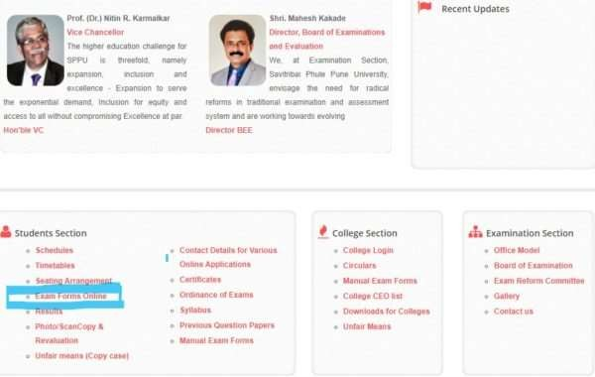
- 5th Step – A new page will open. Now the list of instructions will be displayed on the screen. Read the instructions carefully.

- 6th Step – Scroll down the page. A list of links will be tabulated. Now click on any of the links.

- 7th Step – The page will be directed. Now click on the Login button.

- 8th Step – A new page will open. If you already have an account click on “Login”.

- 9th Step – If you don’t have an account, click on the “Create Account”.

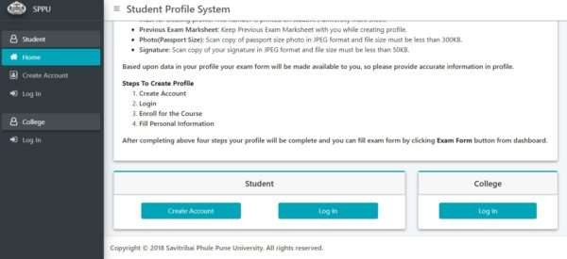

Pune University Exam Form: Create Account

In order to create a new account, follow the steps as listed below:

- 1st Step – Click on the button “Create Account”.

- 2nd Step – A list of instructions will be displayed on the screen. Now read all the instructions carefully.

- 3rd Step – Select “Nationality” from the drop-down menu.

- 4th Step – Enter “Student’s Name” as per previous year Marksheet

- 5th Step – Enter Email ID and Mobile Number.

- 6th Step – Click on “Verify Email ID & Mobile No”.

- 7th Step – Now enter the OTP which you have received in mobile no and email ID.

- 8th Step – Now enter the unique 10 digit code assigned to each college by the university.

- 9th Step – Enter your Eligibility Number. (Every student gets this number when his eligibility is done by the college in eligibility online portal. This number is a must for creating a profile. Please contact your college to get this number. This number is not applicable to International Students.)
- 10th Step – Enter your PRN: Permanent Registration Number (This number is allotted to a student when he/she first appears for university exam. This number is a must for creating a profile. This number is printed on student’s university mark sheet.)

- 11th Step – Enter your Previous Exam Marksheet. (Keep Previous Exam Marksheet with you while creating a profile.)

- 12th Step – Upload your Photo (Passport Size): Scan copy of passport size photo in JPEG format and the file size must be less than 300KB.
- 13th Step – Upload your Signature: Scan copy of your signature in JPEG format and the file size must be less than 50KB.

- 14th Step – Now follow the steps which are listed under UniPune Exam Form/Application Form
– Login Account

UniPune Exam Form/Application Form: Login Account

Now, follow the steps as under to unipune.ac.in log in and fill up the application form:

- 1st Step – Click on “Login By” and select the option which is convenient for you from the drop- down menu.

- 2nd Step – Enter the Password.

- 3rd Step – Resolve the “Captcha”.

- 4th Step – Click on the “Login” button.

- 5th Step – Enroll for the Course.

- 6th Step – Fill up all the Personal Information.

- 7th Step – Click on the ExamFrom from the Dashboard.

- 8th Step – Process the unipune application fee.

- 9th Step – Take the printout of the confirmation page for future reference.

