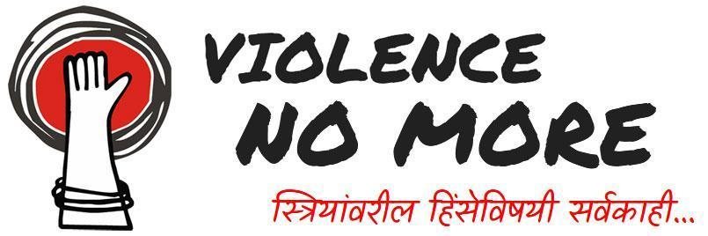

TELL-A-TALE
Online Short Story Writing Competition

ILS Law College in collaboration with SwissAid has been working on a project titled “Addressing Violence against Women”. In pursuance of the same, we bring to you a Short Story Writing Competition.

Theme: Gender Based Discrimination

Submission Guidelines:
- The maximum word count is 800 words. Participants can also attach a pictorial representation of their story (however this is not mandatory).
- Language: Hindi/Marathi
- Fiction or Non-fiction stories
- Only Individual Participation is allowed.
- Only one submission per author will be accepted. Multiple or incomplete submissions would lead to disqualification.
- Plagiarism of any sort will result in immediate disqualification

Eligibility
All students of ILS Law College: Undergraduate and Postgraduate
Submission Procedure:
- The story must be submitted on the following email in PDF format : projectvaw@ilslaw.in
- The formatting of the story shall be as follows:
  - Headings: Times New Roman, Bold Font, Font Size: 16, Line Spacing: 1.5
  - Body: Times New Roman, Font Size: 12, Line Spacing: 1.5
  - Footnotes: Times New Roman, Font Size: 10, Line Spacing: 1.0
- The copyright of the Short Story will be vested with ILS Law College and students CANNOT claim copyright to the story submitted
- Last date of submission: December 15, 2022 till 11.59 pm
- Declaration of result and winners: December 31, 2022.
Assessment Criteria:
All the entries will be judged on the following parameters:
- Creativity and originality
- Adherence to the theme and word limit
- Language and Grammar
- Articulation of idea

Fee Details
No registration fees.

Prizes
Acknowledgement and Awards:
- 1st Prize: 5000/- INR
- 2nd Prize: 3000/- INR
- 3rd Prize 2000/- INR

Selection Process
- The selection will be made by the constituted Screening Committee formed for this purpose.
- The selected story will be published on the project website and will be utilized by ILS Law College and SwissAid for creating awareness on the issue

Faculty Coordinator:
Ms. Divya Mittal

